**USER EXPERIENCE DESIGN FOR TWO MUSIC STREAMING PLATFORMS AND PROTOTYPING**

TABLE OF CONTENTS

1. INTRODUCTION 3

2. GUIDELINES AND STANDARDS 3

3. USABILITY REPORT 4

4.USER PERSONAS 18

5.DECIDING PERSONAS 19

6.PERSONAS 22

7.SCENARIOS 23

8.PROTOTYPE DESIGN 24

9.CONCLUSIONS 31

10.REFERENCES 32

# 1. INTRODUCTION

In this study, usability and usability issues have been evaluated by using one of most famous heuristics, Nielsen’s 10 heuristics in order to create a mid-fidelity prototype focusing on creating playlists either individually or as a group.

A heuristic evaluation has been undertaken for two different music streaming platform Spotify and YouTube Music. Two different personas and concreate scenarios have been designed. Findings gathered evaluation has also been into consideration while creating the prototype.

# 2. GUIDELINES AND STANDARDS

Usability testing is a methodology which used measure how well-designed a product or service is for its intended audience, whether it's a portal, software package, or smartphone app (Nielsen, 1993). It includes watching a sample of people while they use the product or service and analysing their actions to uncover any problems or potential improvements (Rubin & Chisnell, 2008).

Usability testing can offer insightful information about user behaviour and preferences, which can help designers make decisions and enhance the user experience as a whole (Hertzum & Jacobsen, 2001). Usability testing can assist in cutting down on the cost and time necessary for redesign and development by discovering usability concerns early in the design process (Hassenzahl & Tractinsky, 2006).

A good user experience is provided by UI and UX text to ensure the interface of any website can be successful (Pant, 2015)

Various criteria are considered for inspecting the interface to ensure that they are usable. An efficient method through which the design defects that impact the user's experience can be measured is Nielsen heuristics among various testing designing methods for interface (Yáñez- Gómez Rosa et al. 2017). Based on Nielsen's heuristics, the aesthetic and design of the interface is analysed for improving deficiency flexibility and recall features. (Szabo,2017)

Nielsen heuristics can be modified depending on the evaluator and the product. It takes a lot of resources, but user testing generates effective results when it comes to creating and evolving the product's user experience. (Szabo, 2017)

Nielsan’s 10 heuristics (Nielsan,1995) are a set of design principles developed by Jacob Nielsan to help evaluate the usability of interactive systems. The 10 heuristics are listed as follows (Nielsan, NNGROUP):

1. Visibility of system status
2. Match between system and the real world
3. User control and freedom
4. Consistency and standards
5. Error prevention
6. Recognition rather than recall
7. Flexibility and efficiency of use
8. Aesthetic and minimalist design
9. Help users recognize, diagnose, and recover from errors
10. 10.Help and documentation.

For all the heuristics mentioned above have been used during the evaluation for both platforms.

# 3. USABILITY REPORT

In this study, YouTube Music and Spotify have been evaluated in order to undertake a usability test, with no paid- membership, aligning with the most used guidelines in the industry. Evaluation is based on the desktop version of those streaming platforms; MacBook Air 13’ with Safari web browser is used as the medium.

Best practices and usability issues identified during the evaluation can be seen with screenshots and explanations as follows:

**1.Visibility of system status**

Tabs and menu items allow user to see where they are visiting. Active pages visited can be understood with the change of colours or backgrounds on the either icons or menus as seen below:

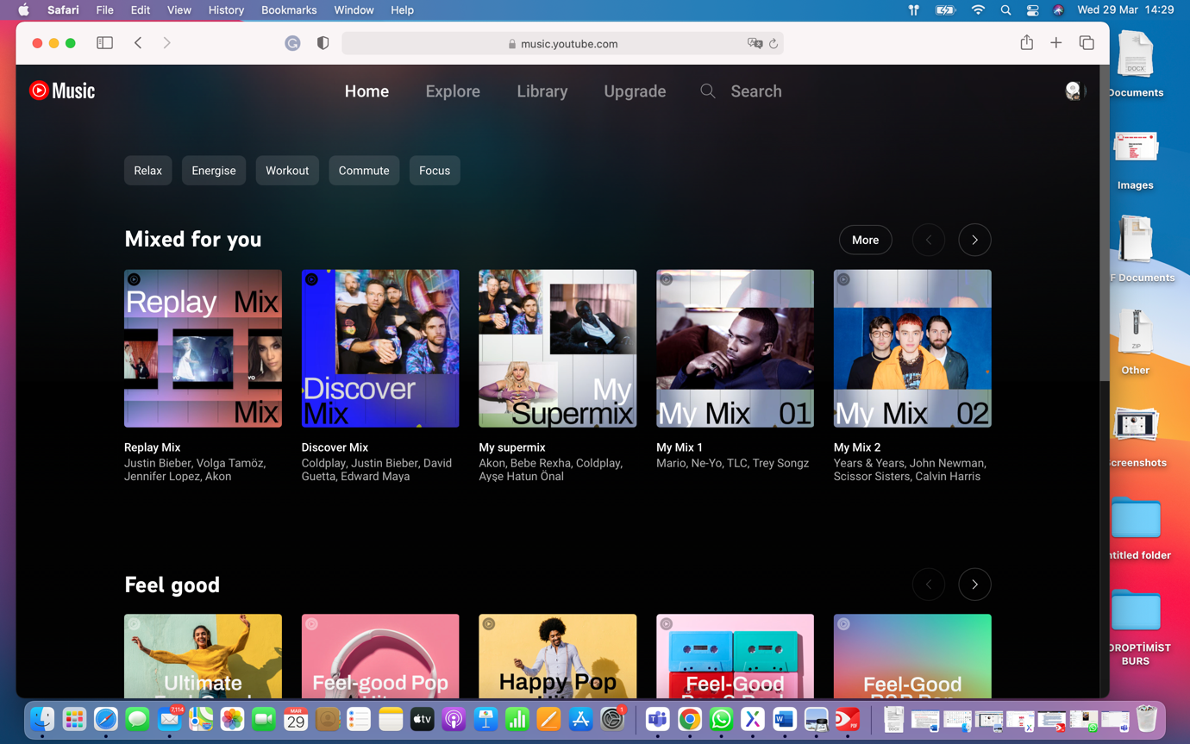

Moreover, YouTube Music follows the conventions of Google in terms of visibility. When a user adds or removes a song from the playlist, a message informing the user appears on the left bottom of the page.

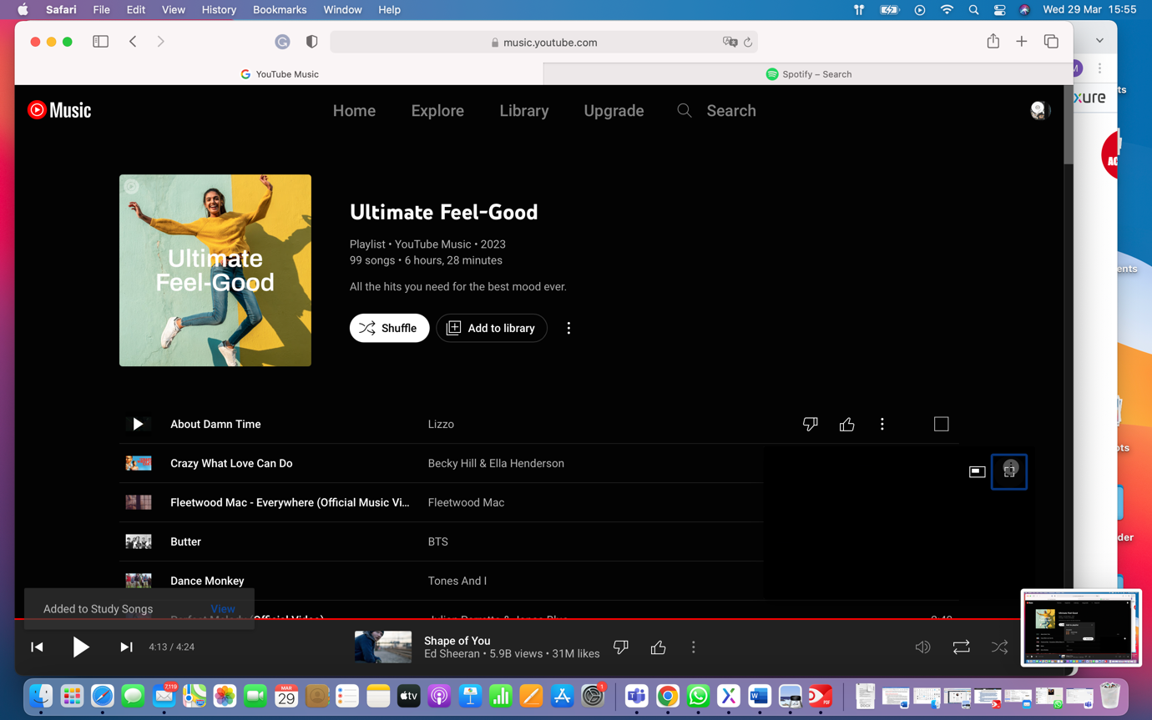

In a similar way, Spotify follows the same pattern on the side menu as well as other elements of the platform. Additionally, in such dark backgrounds, the design of blue message box in

with white text color which appears when adding a song to a playlist makes it more visible in comparison to YouTube Music’s feedback in dark pattern.

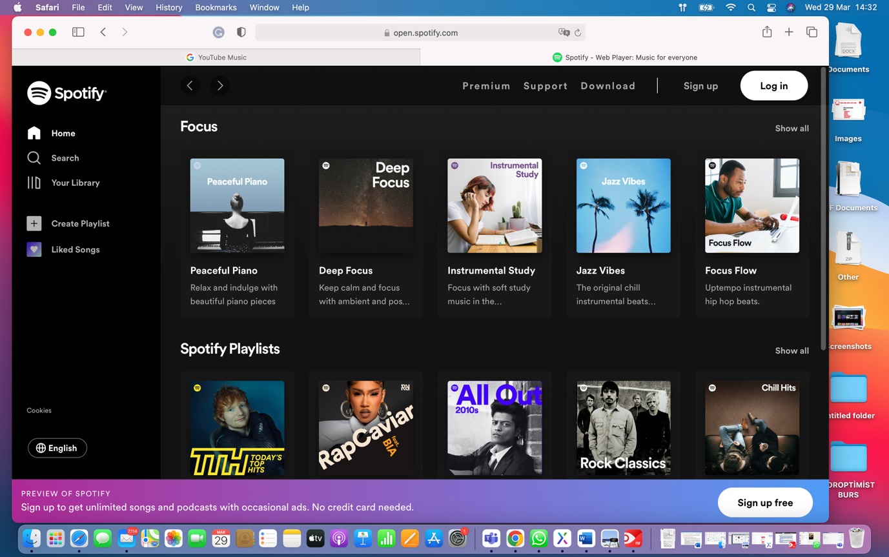

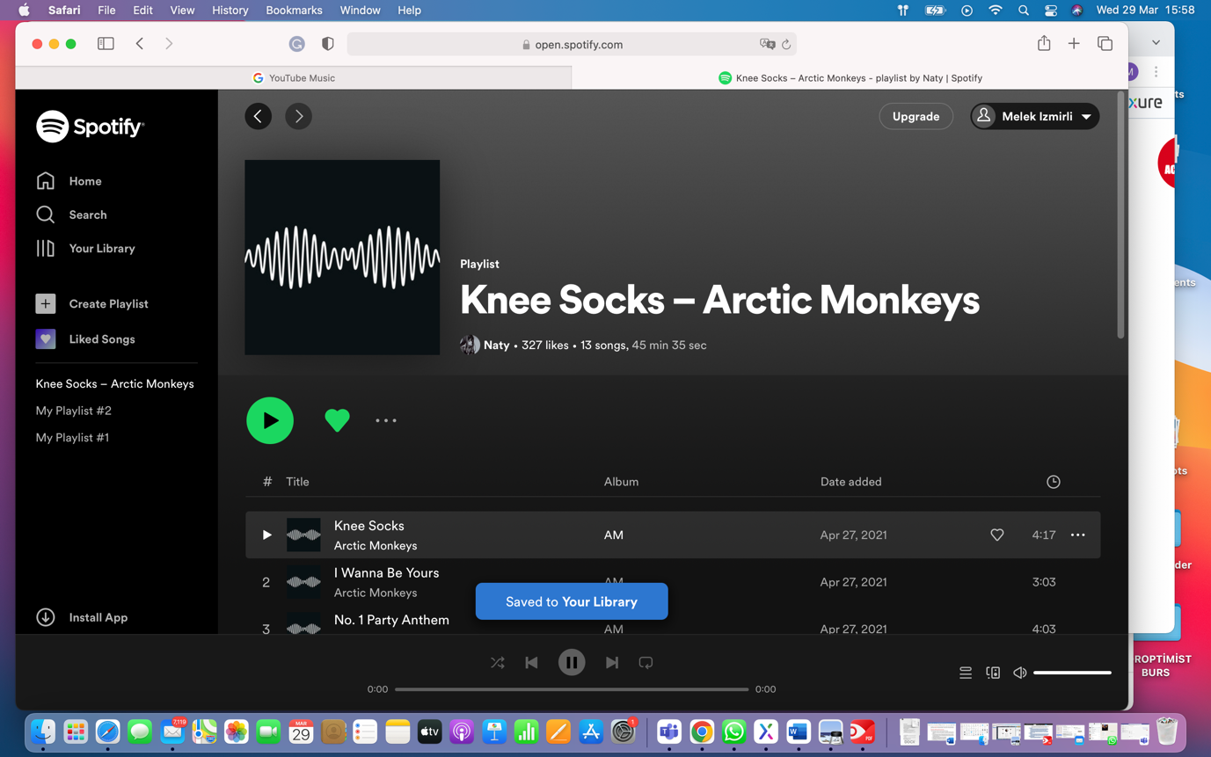

**2.Match between system and the real world.**

For both platforms, the language encountered throughout the experience on platforms is easy to understand and related to user’s previous experience either on the digital world or in real life. Designing elements based on Skeuomorphism (Oxford,2021) that explained as mimicking the physical world in their appearance and behaviour in graphic user interface also contributes the quality of user experience and user interface. It can be seen that the player has the same icons as in physical music devices that we used or use in our daily life. Plus, the images seen on the help page are successfully related with the content that are to be displayed.

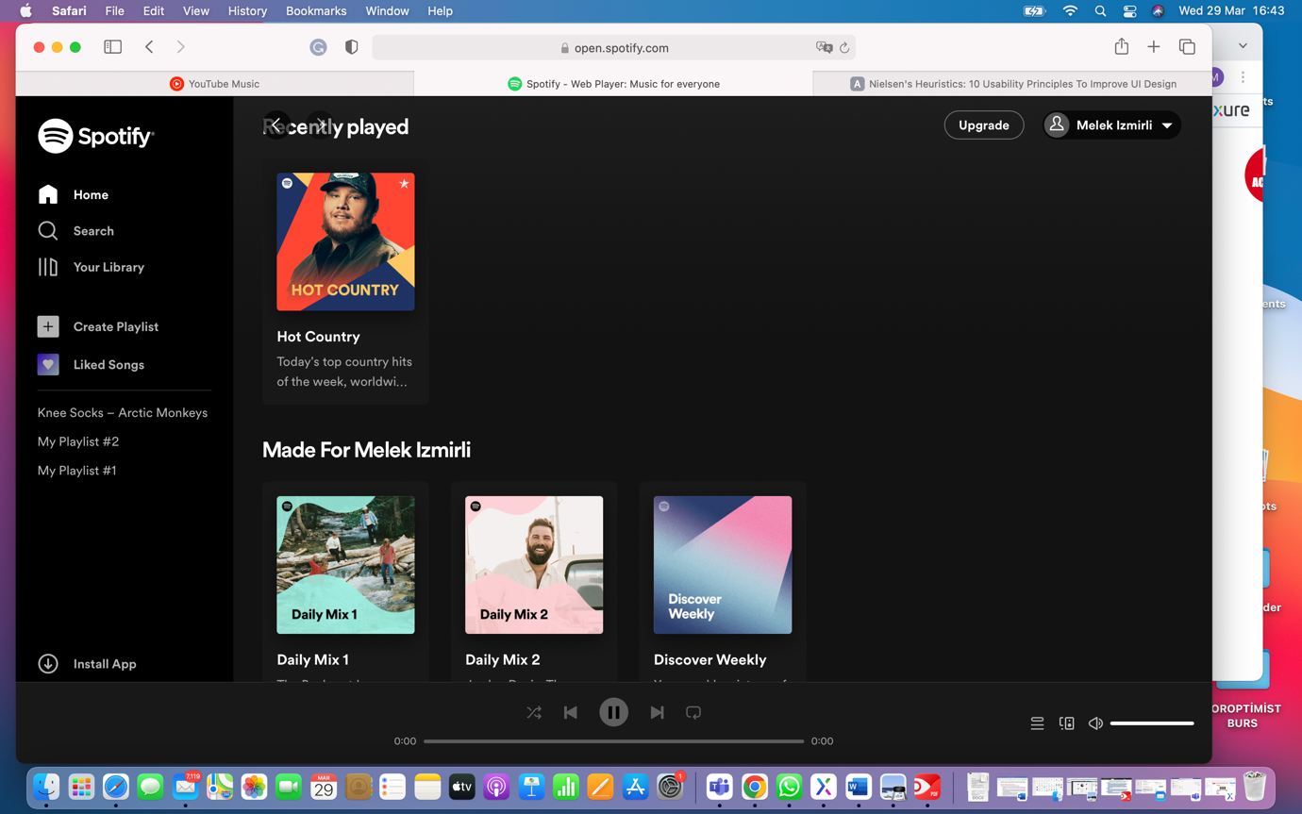

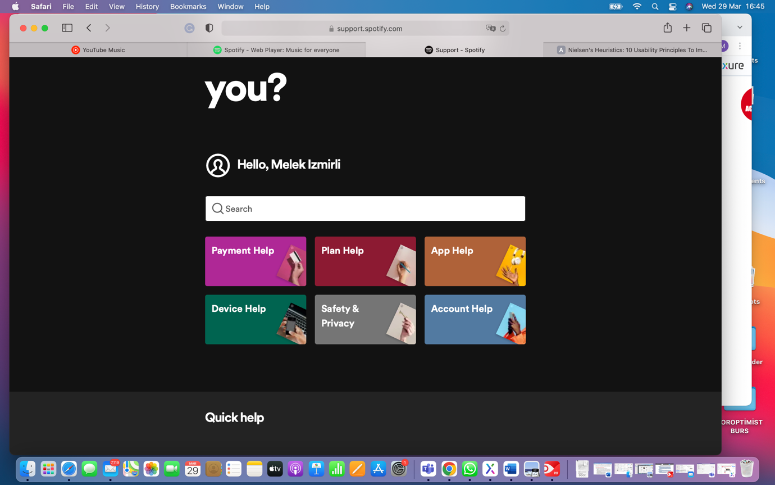

In both platforms, it is also essential that the image located on the suggested playlists are related to the content in the playlists which also increase perception both by looking and reading. While YouTube Music chooses more realistic images, Spotify makes its choice on futuristic features.

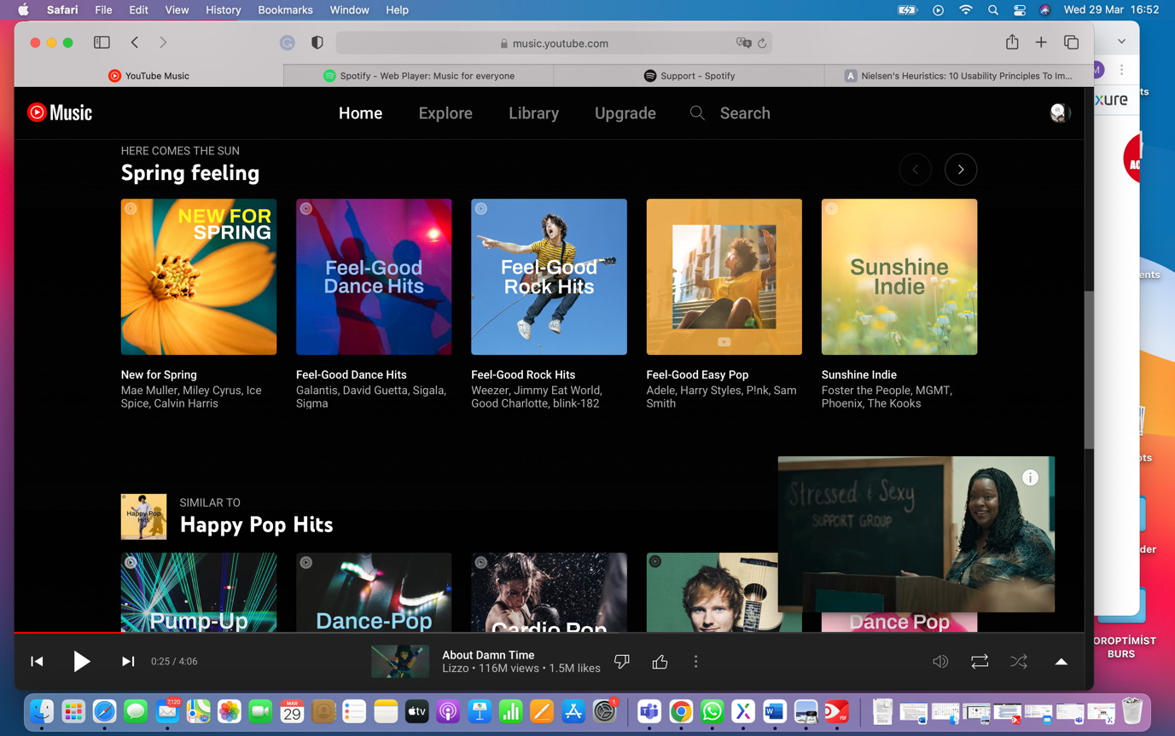

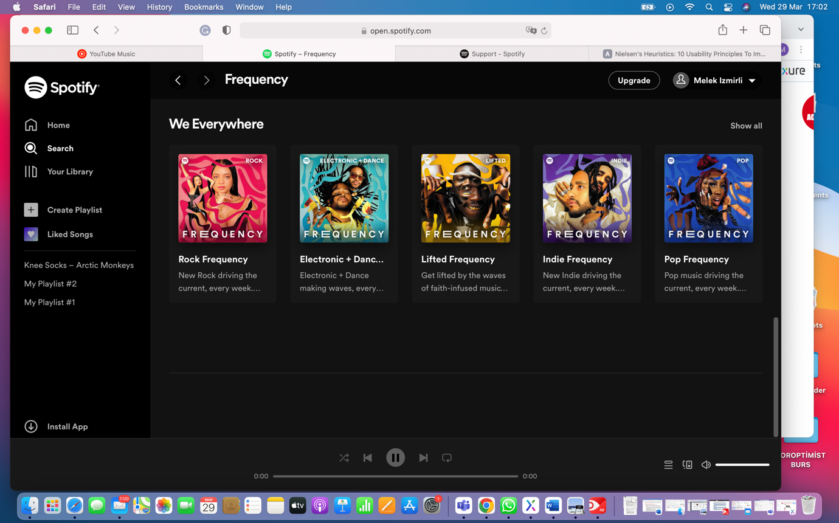

**3. User control and freedom**

For this heuristic, it is clear that Spotify is a good feature that allows user to recover deleted playlists as illustrated below:

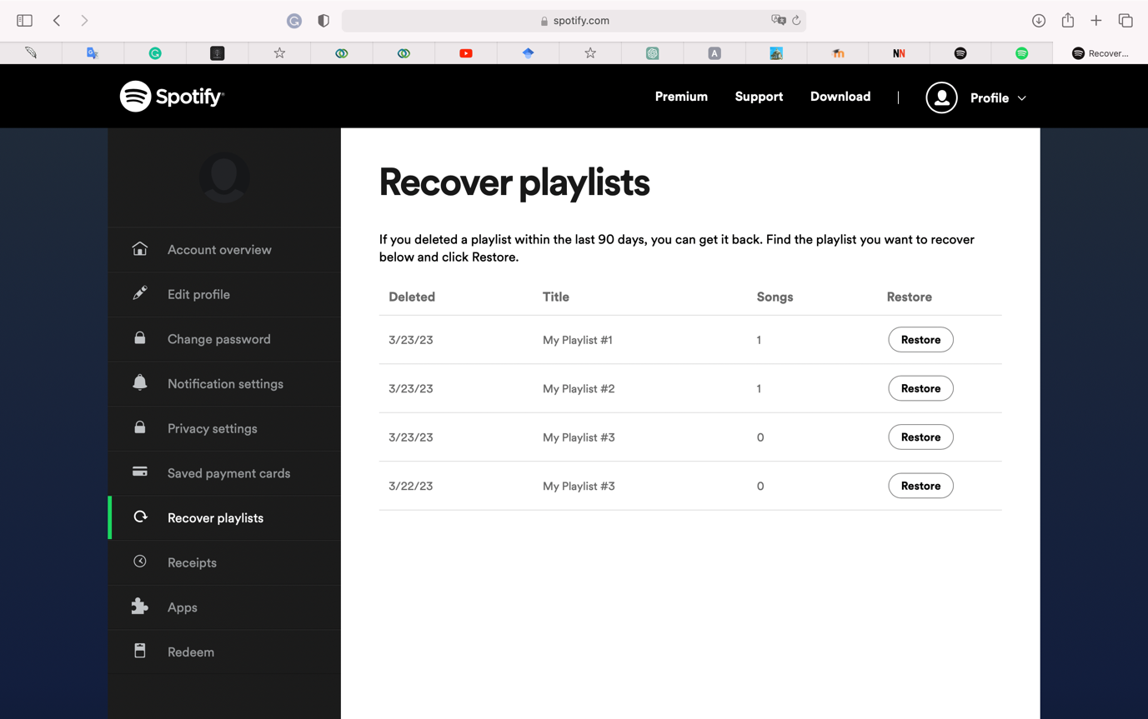

On the contrary to this, it is expected to see a similar solution from YouTube Music to take the results of actions back as it is seen in many Google products. Instead, this appears when a playlist deleted:

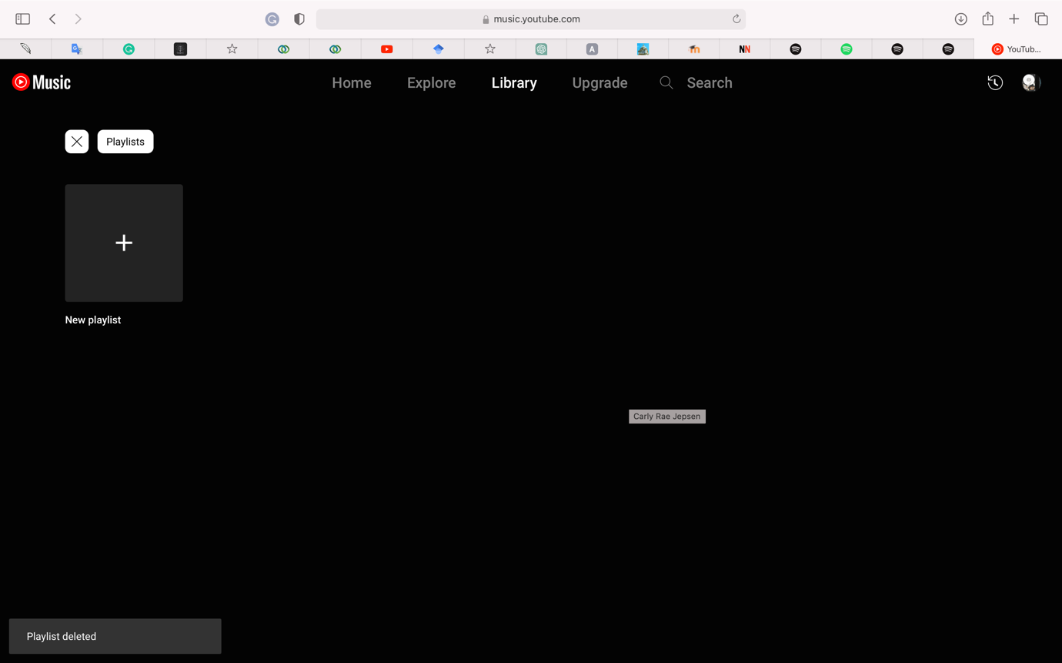

**4.Consistency and Standards**

For both streaming platforms, it can be said that consistent and standard designs welcome users. Dark backgrounds conveniently highlight albums, playlists, and artists placed on the pages.

addition to this, there is strong consistency in terms of design elements such colours, buttons and forms.



It can be seen that as a member of Google, YouTube Music has a similar interface with YouTube which increase familiarity for the users choosing other Google products. On the other hand, there is a compatibility issue for the safari browser that is no head icon for the tabs. This makes it hard to find the page among other tabs on the browser and this may lead users into confusion whether they use Google, Youtube or any other products.

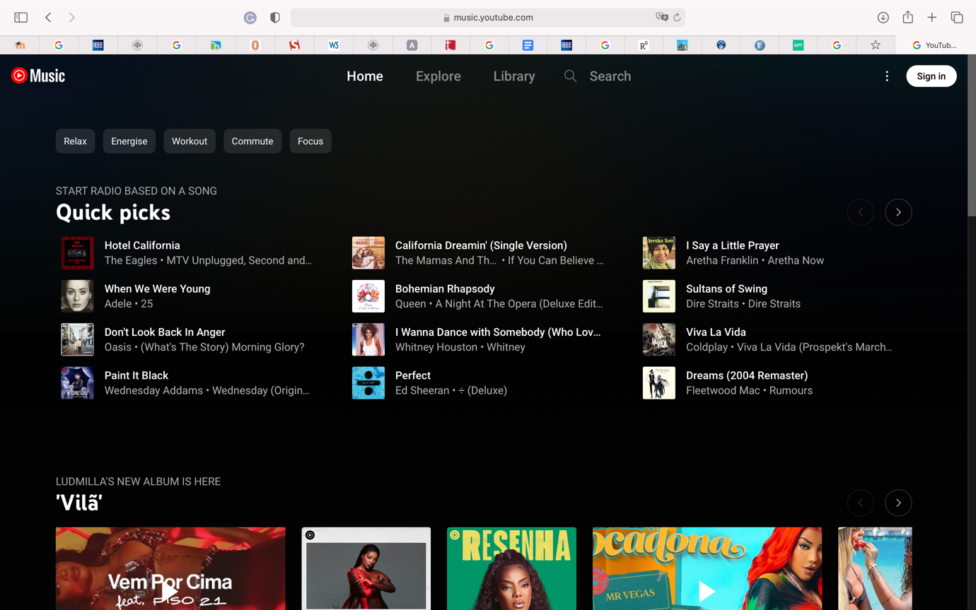

This compatibility issue is not seen at Chrome Browser as seen below:

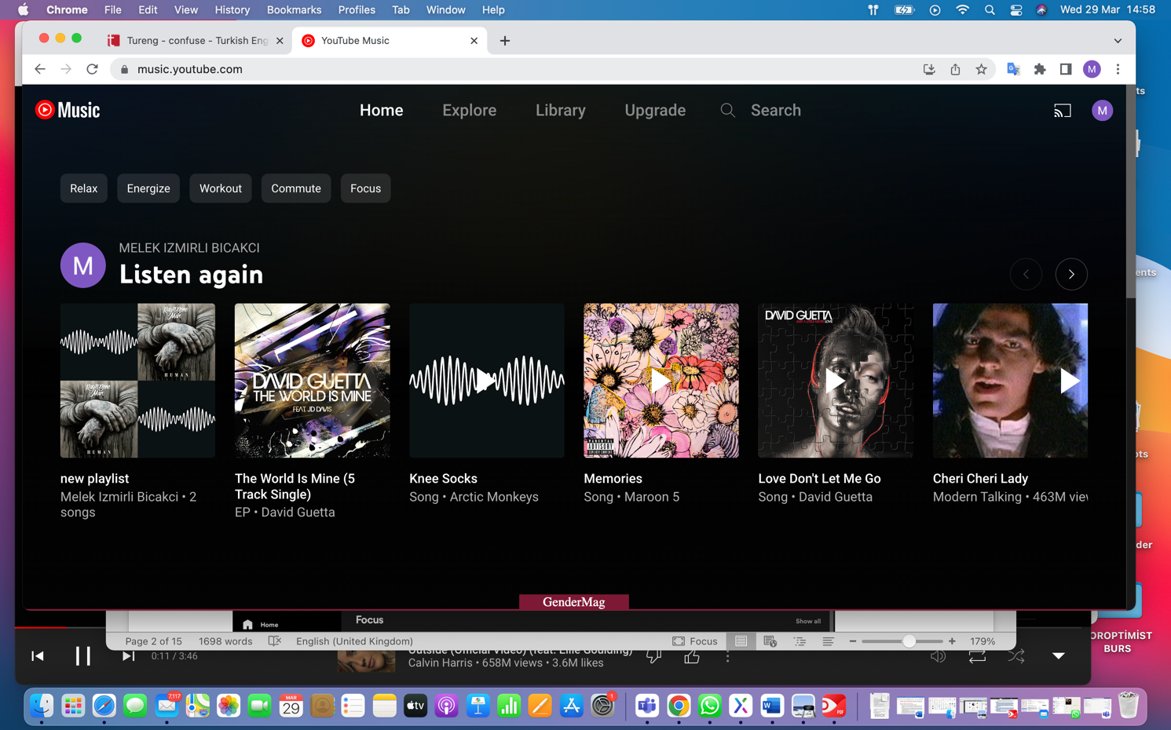



Spotify shows a different preference in terms of the layout by adding a side menu while YouTube Music’s choice is to keep the menu on top. Moreover, forward and backward options that as left and right arrows are shown in red boxes above ease navigation between pages to be visited.

**5.Error prevention**

Without having a playlist, YouTube don’t let users to add a song to playlist. The error made by users are explained in a way that users can easily understand.

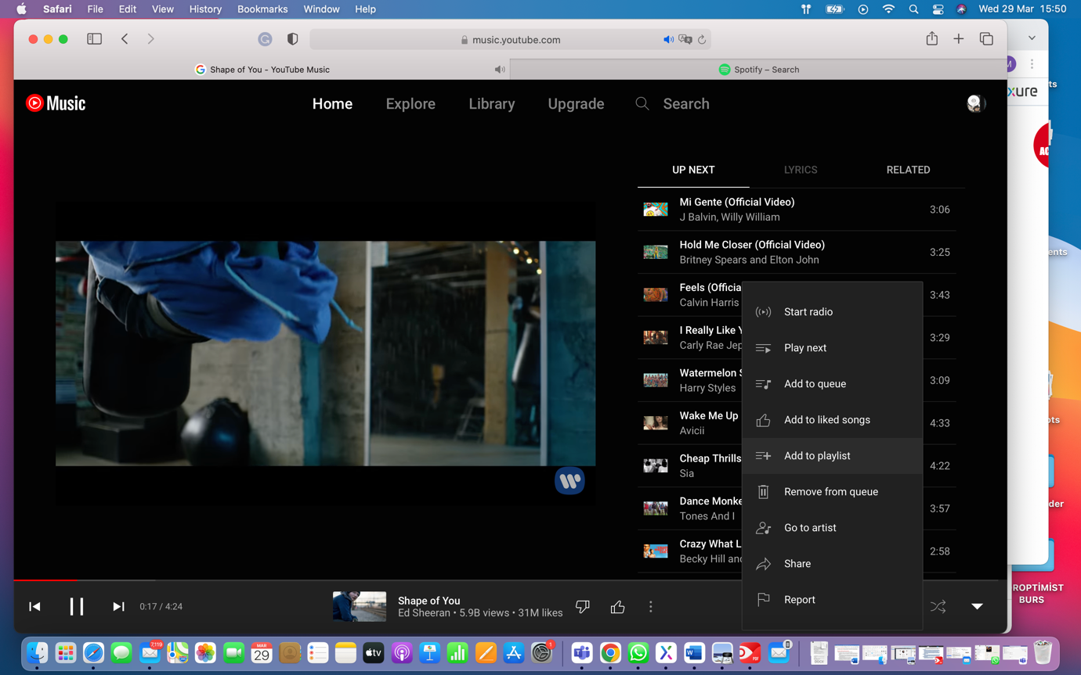

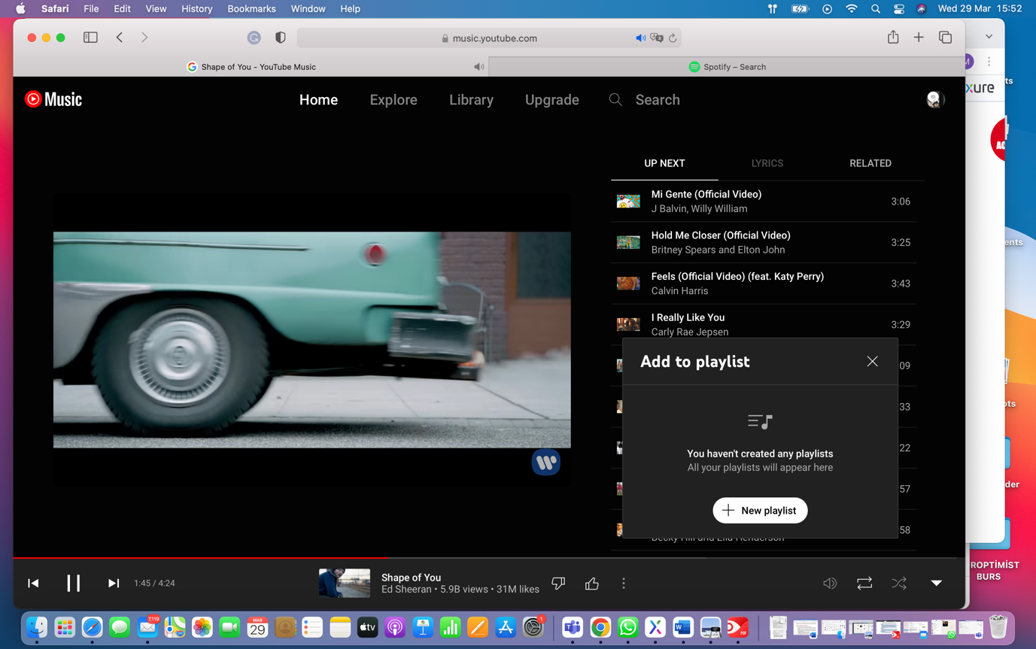

When updating profile in Spotify, it is important to use predefined areas that users make a choice among list elements, preventing undesired data entries. Controversially, Date of Birth field is highlighted when a wrong data is entered regarding the days of a month. But, there is no clear message directing users how to recover their mistakes.

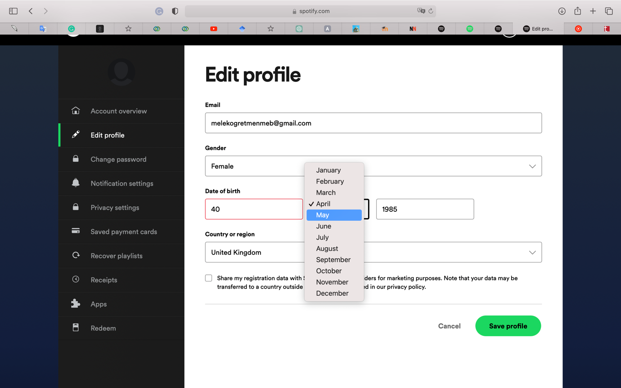

**6) Recognition rather than recall**

Spotify enables users to remind their previous experience and searches via either elastic engine or showing previous actions done by users.

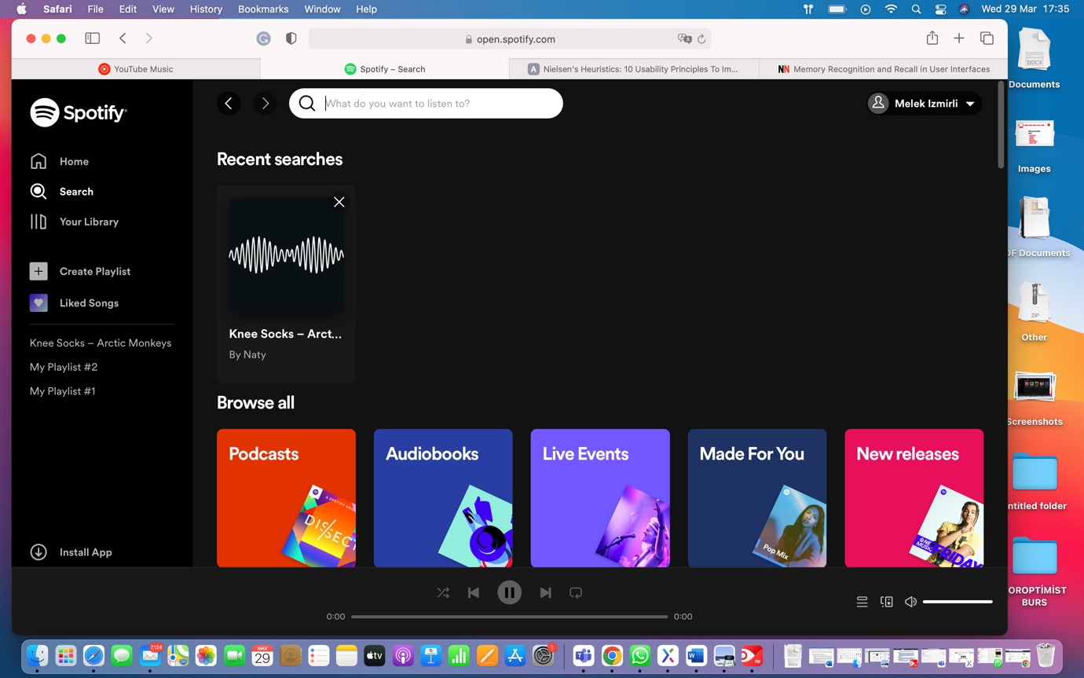

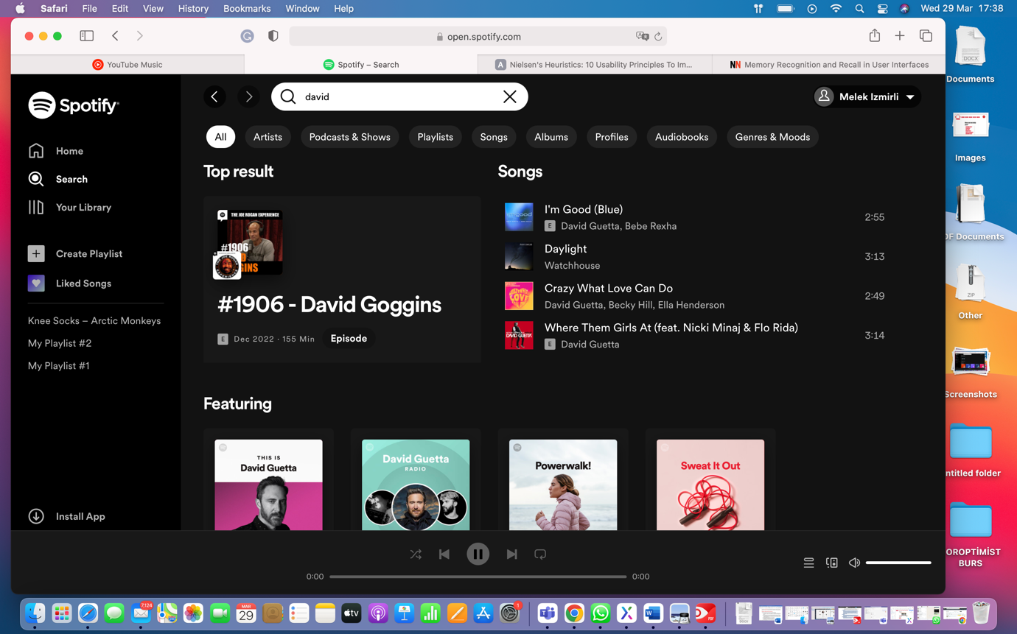

It is also seen on YouTube Music enables user to search and makes them recall.

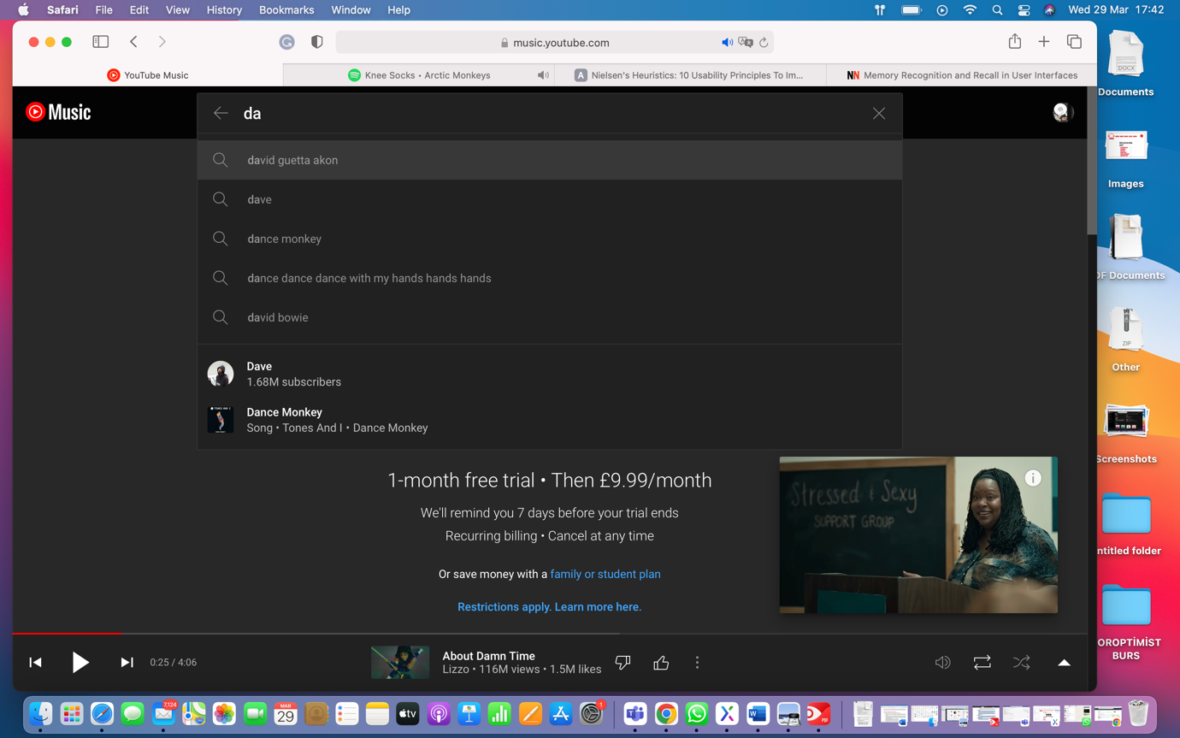

**7) Flexibility and efficiency of use**

Another major point is whether the system is flexible for different users. For experienced users, dragging playing song and dropping it onto a playlist on the left-hand pane is one of the flexible alternatives.

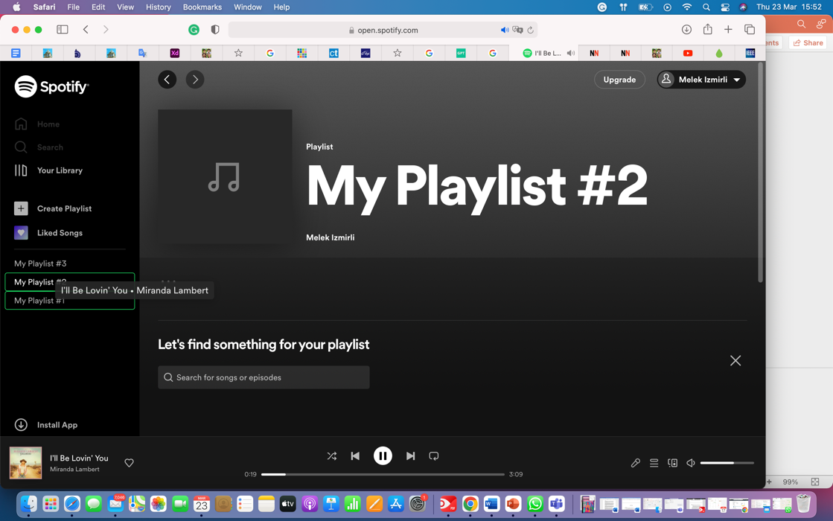

For novice users, it is also possible to add a song to a playlist in other ways that can be done via options menu.

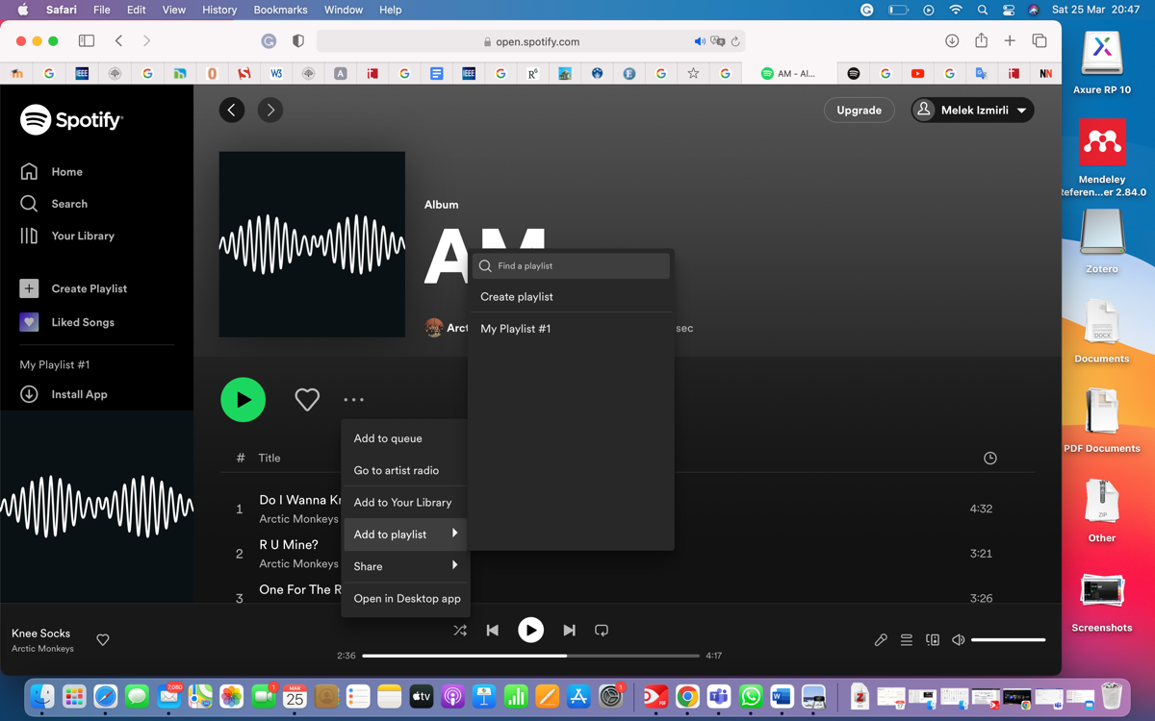

For YouTube Music, there are some properties that can be used more flexibly for expert users as well. In order to organise a playlist, a song in the list can be dragged and repositioned.

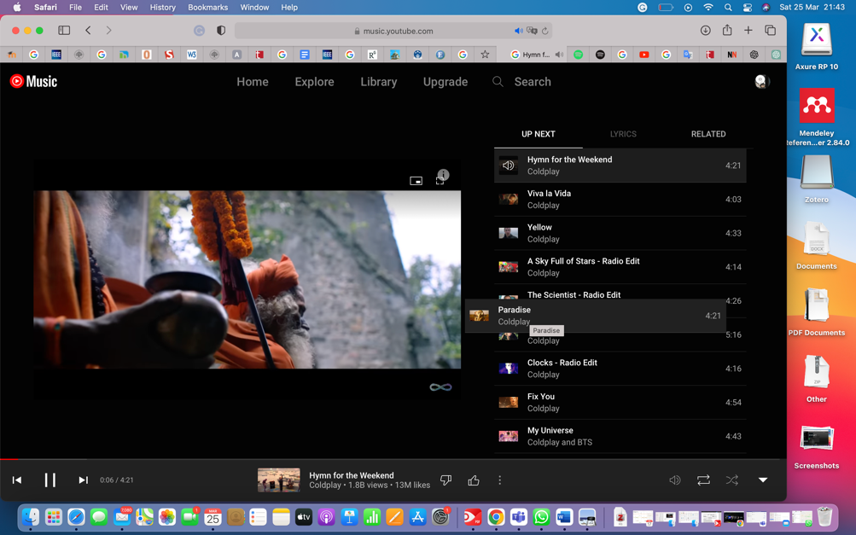

**8) Aesthetic and minimalist design**

For both platforms, it can be said that there is no unrelated content, each element on the pages is related to each other. Besides that, designs help user to accomplish their goals.

**9) Help users recognize, diagnose, and recover from errors**

YouTube Music warns users when they attempting to delete items with highlighted buttons and in a window.

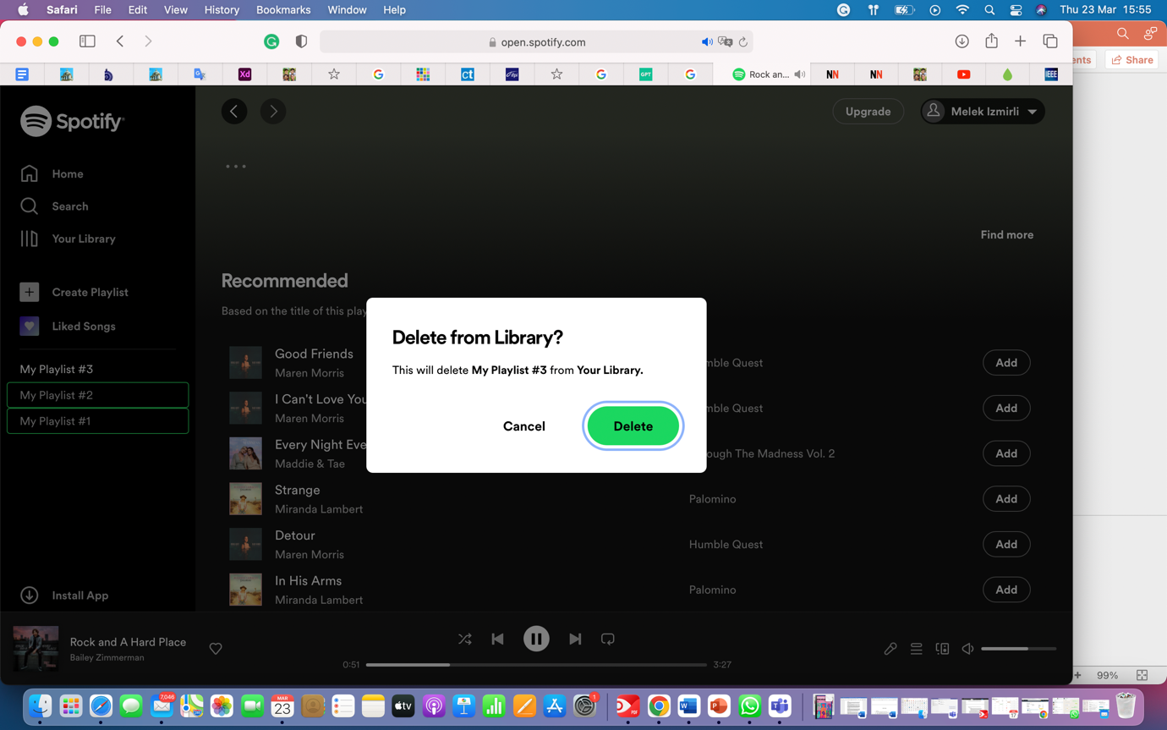

For unexpected errors, messages delivered to user are understandable and do not include technical expressions, advise users what to do for solving problem occurred.

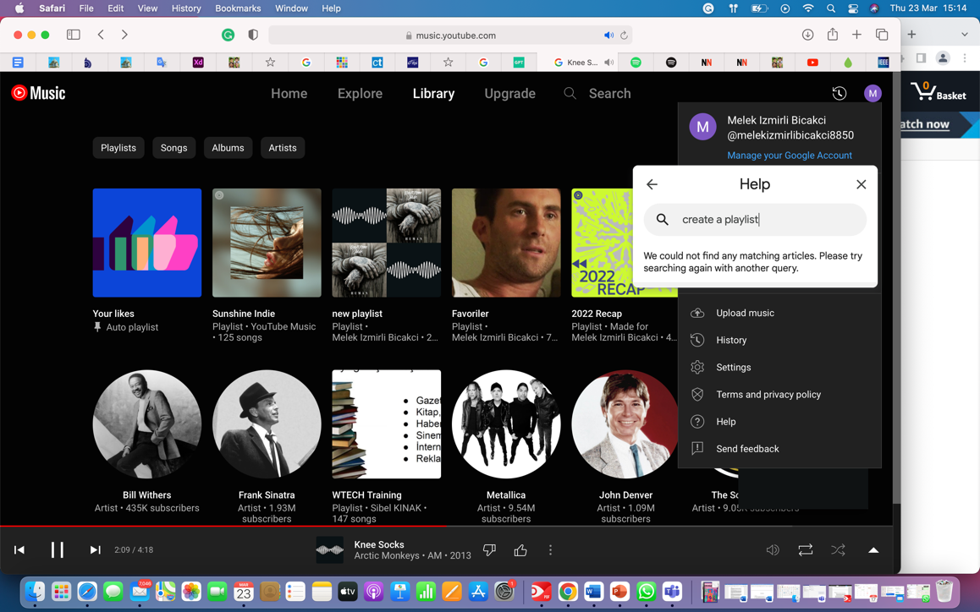

**10.Help and Documentation**

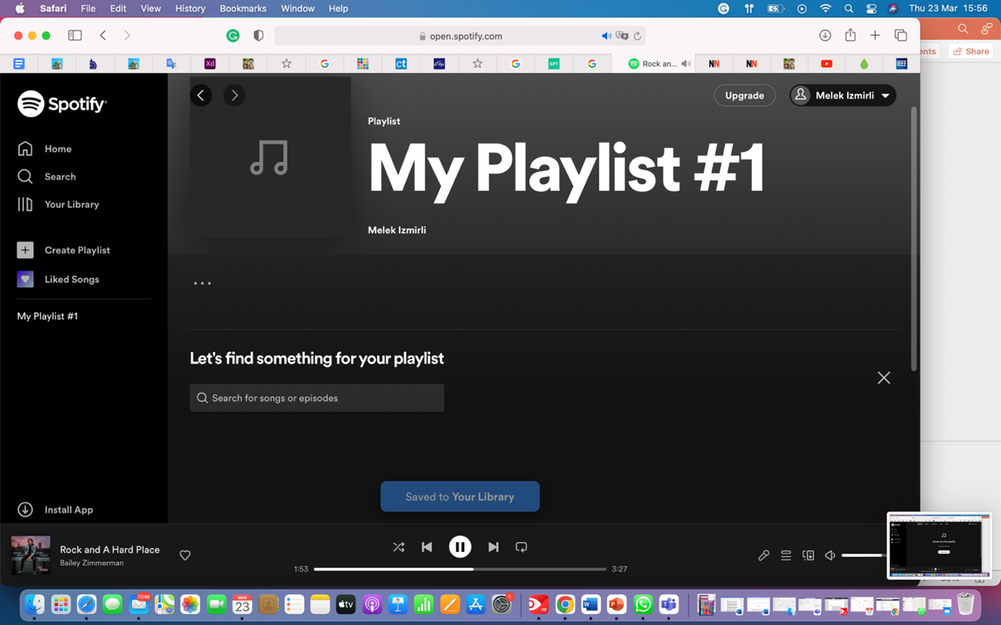According to Nielsen’s Heuristic, help plays an important role in the usability of a system. During all experience, Spotify provide both proactive and reactive helps at the same time, as well as supporting users with an additional support page which is well organised and categorised, most of the help articles enriched by videos and subtitles.

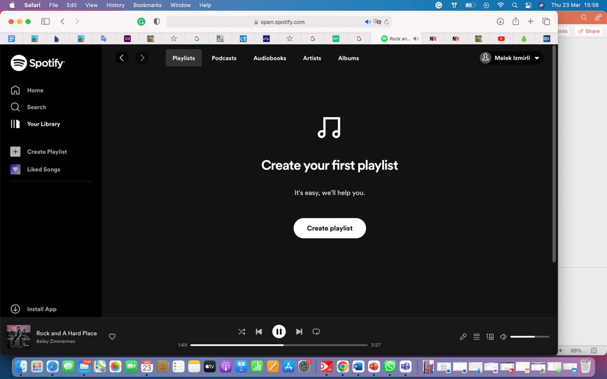

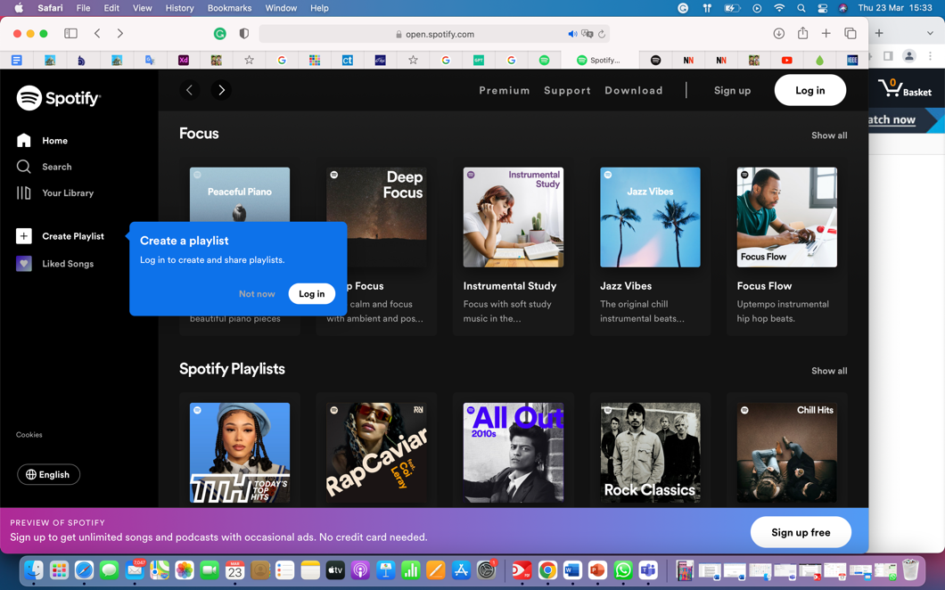

It is also possible to reach for help without signing up for Spotify. The search box located on the homepage enables users to search a wide range of subjects as well as music. Search is supported by a search engine that shows related subjects when a keyword is started typing.

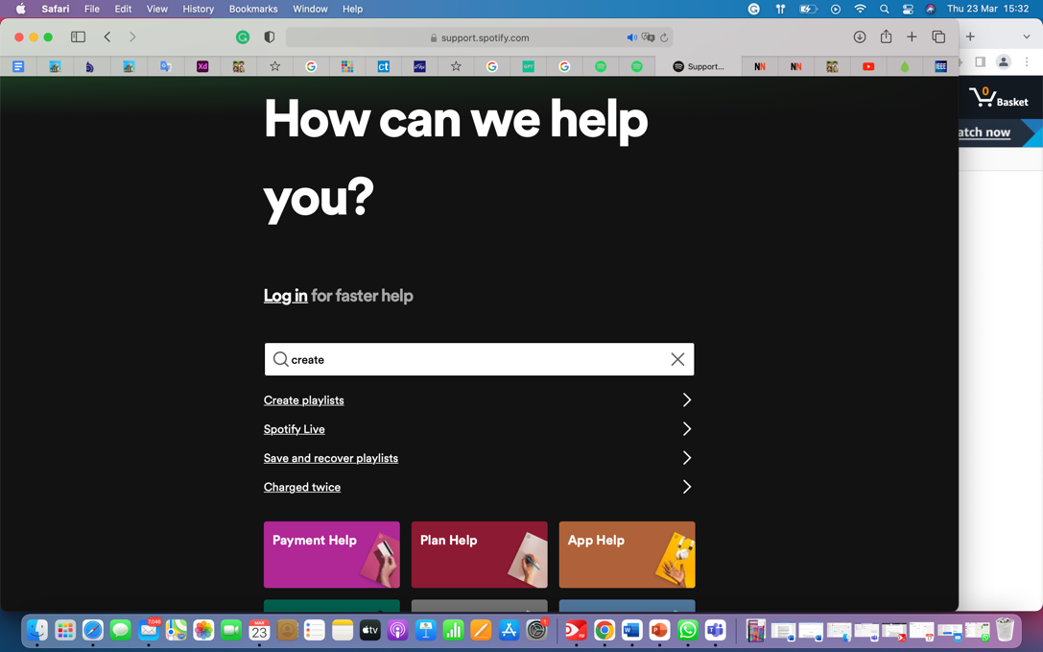

On the support interface, for each different platform help is provided in different sections. In order to increase accessibility to help, videos with subtitles allowing users to get help in different situations.

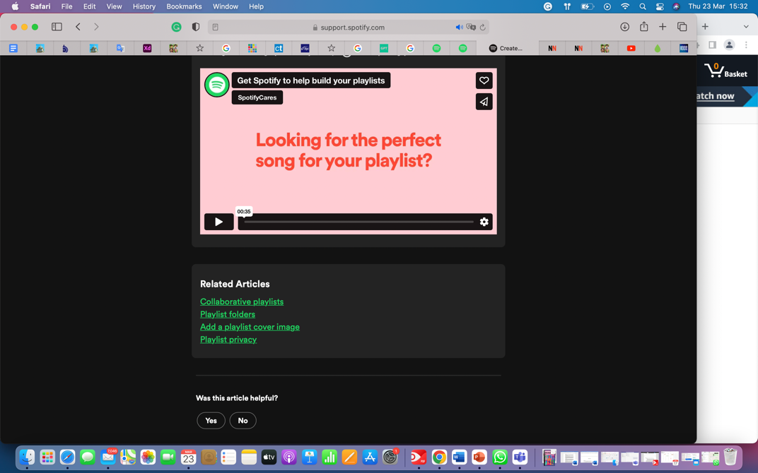

On the contrary to this, YouTube Music's help mechanism has some usability issues. Search Box located on the home page is not able to search content except for songs or videos. Moreover, the results shown after the search only include music content. On the profile menu, it is possible to reach a help section allowing users to search and access help content. Similar to Spotify, help is organised based on topics and device used, enhanced by videos and subtitles in YouTube Music.

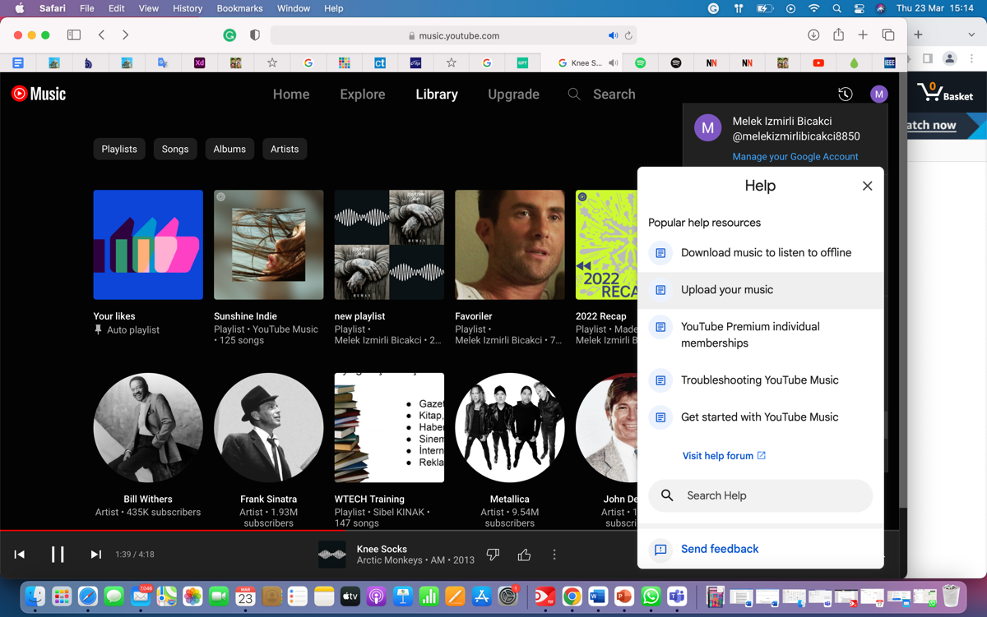

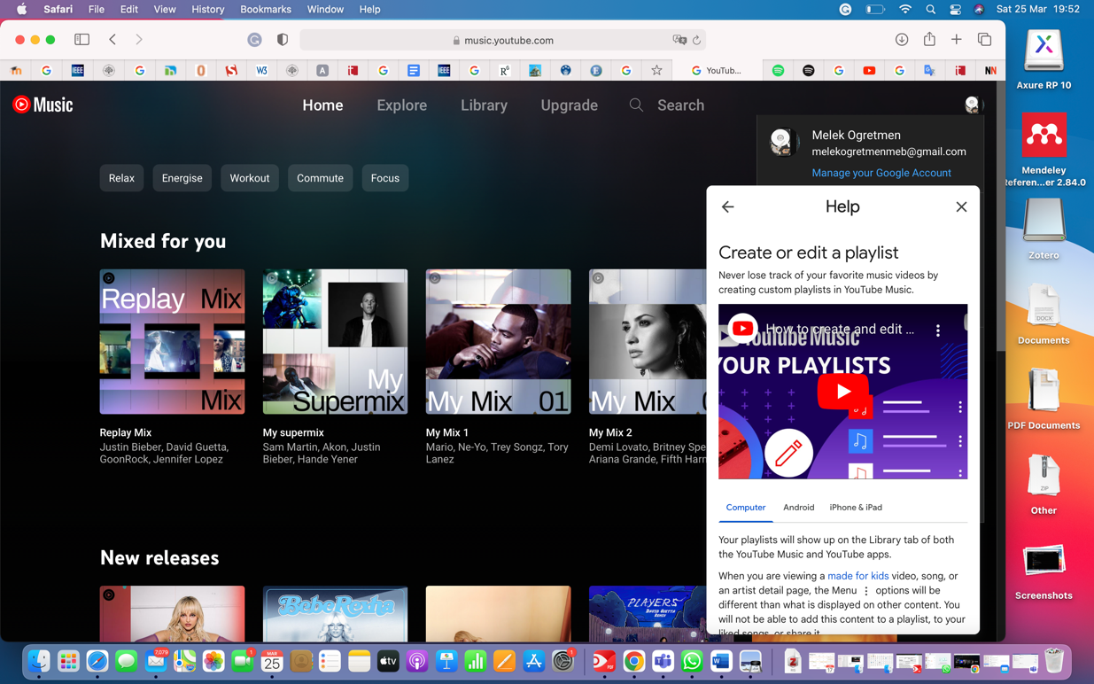

# 4.USER PERSONAS

"Person" refers to a fictional character that represents a group of users with similar goals, behaviours, and needs in UX design. Personas give designers a better understanding of what users want, and how to design products and experiences that meet those needs.

Calde, Goodwin & Reimann (2002) gives a slightly more detailed definition:”

User models, or personas, are fictional, detailed archetypical characters that represent distinct groupings of behaviours, goals and motivations observed and identified during the research phase**.” (Blomkvist, S., 2002.)**

With the persona method, designers can develop fictional personas to stand in for certain user types or user groups. In order to generate user-centered solutions that satisfy the demands of the target audience, personas are utilised in design and development. Personas help teams create goods and services that address users' demands by giving them a shared language and understanding (Cooper et al., 2007).

Doing user research, combining user data, and constructing a narrative that represents the user's objectives, behaviours, and pain points are all steps in the process of creating a strong persona (Nielsen, 2002). To develop a strong persona, employ the techniques listed below:

1. Do user research. Using user interviews, surveys, and other techniques, collect information on user behaviours, preferences, and pain areas.

2. Produced data: Examine the information and find recurring themes and patterns.

3. Create personas: Based on the combined data, develop personas that represent various user categories.

4. Add details: To give the persona more life, create a narrative that encapsulates the user's objectives, coping mechanisms, and pain points.

5. Verify: Confirm that the personas adequately describe the target audience by testing and validating them with users. (Nielsen, 2002).

# 5.DECIDING PERSONAS

The findings of a survey on the adoption of online music streaming in the UK of March 2021 looked at respondents' online content consumption habits over the previous three months. The survey discovered that respondents between the ages of 16 and 24 were most likely to stream music. The second-largest age groupings for music streamers were those between the ages of 35 and 44 and 25 to 34, with older users' usage gradually decreasing beyond the age of 44. (Marie Charlotte Götting, Statistica)

Because of the majority of users of these streaming platforms are among these top two groups, personas age ranges also have been decided in a same way, one is 38 years old, another one is 25.

In addition to this, raising the awareness on gender-biased designs in terms of the differentiations of individuals’ cognitive styles, one of the features of GenderMag (GenderMag Project, Gendermag.org) which is a methodology developed by the researchers from University of Washington has also been implemented into personas.

GenderMag methodology is a human-centered design methodology to address gender-inclusive design problems in software. According to this method, it can be a useful tool to tackle with gender-biased interfaces while designing and developing software products. (Burnett et al,2016)

The GenderMag technique involves a collection of heuristics, or recommendations, for evaluating user interfaces from a gender-inclusive perspective. These heuristics attempt to ensure that user interfaces are created in a way that is accessible and efficient for all users, regardless of gender, and are based on research into gender differences in cognition and communication styles. (Burnett et al,2016)

This methodology consists of four instant personas measuring different cognitive style in five areas as follows:

1. Motivations
2. Computer self-efficacy
3. Attitude toward risk
4. Information processing style
5. Learning (Burnett et al,2016)

In this perspective, to understand whether computer efficacy effects usability and inclusivity of a system, Computer efficacy level has been added to both personas in the design process.

First persona has a limited knowledge of computer use, while the second one has a strong command of using technology.

An example of personas used for Gendermag methodology retrieved from official website of the project can be seen as follows:

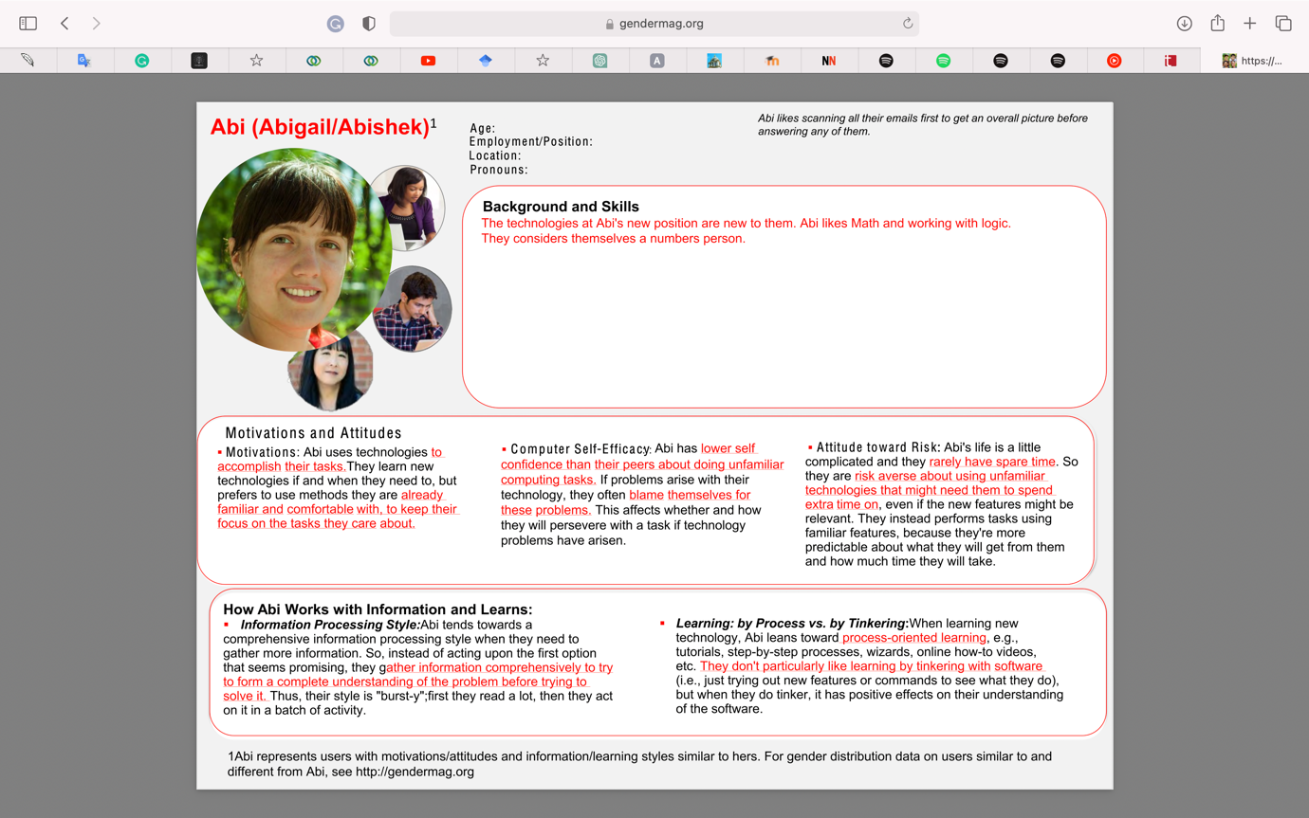

It can be seen that one of personas is a member of Generation Y, while the second one is from Generation X. According to research, Gen Z is more reliable to social issues (Williams, A. & Hodges, N. J., (2020) and they believe businesses have responsibility on this (Cheung, J., Glass, S., McCarty, D., & Wong, C.K. (2017). Thus, one of recent social problems of today’s world women in STEM (Miner et al, 2018) has been mentioned on that persona in order to provide a more realistic and justified persona.

According to recent studies, Generation Z ranks climate change, income inequality and poverty to be top causes for concern (Broadbent et al,2017) and believes businesses have a social and environmental responsibility to address such challenges (Cheung, Glass, McCarty & Wong, 2017; Cone Communications, 2017)

Overall, in the creation of personas, personas have been created by changing from different backgrounds, generations, computer efficacies in order to increase inclusivity for different cognitive styles as well as raising the awareness of social issues that women face in everyday life.

# 6.PERSONAS

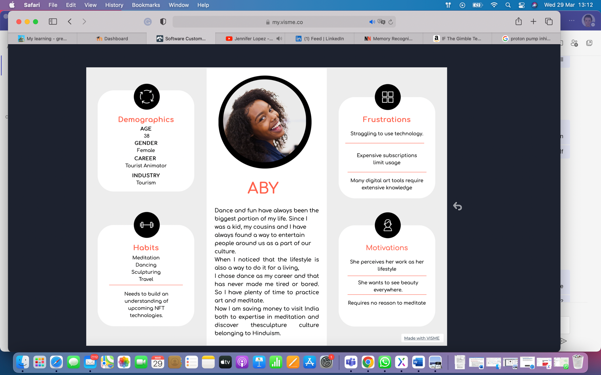

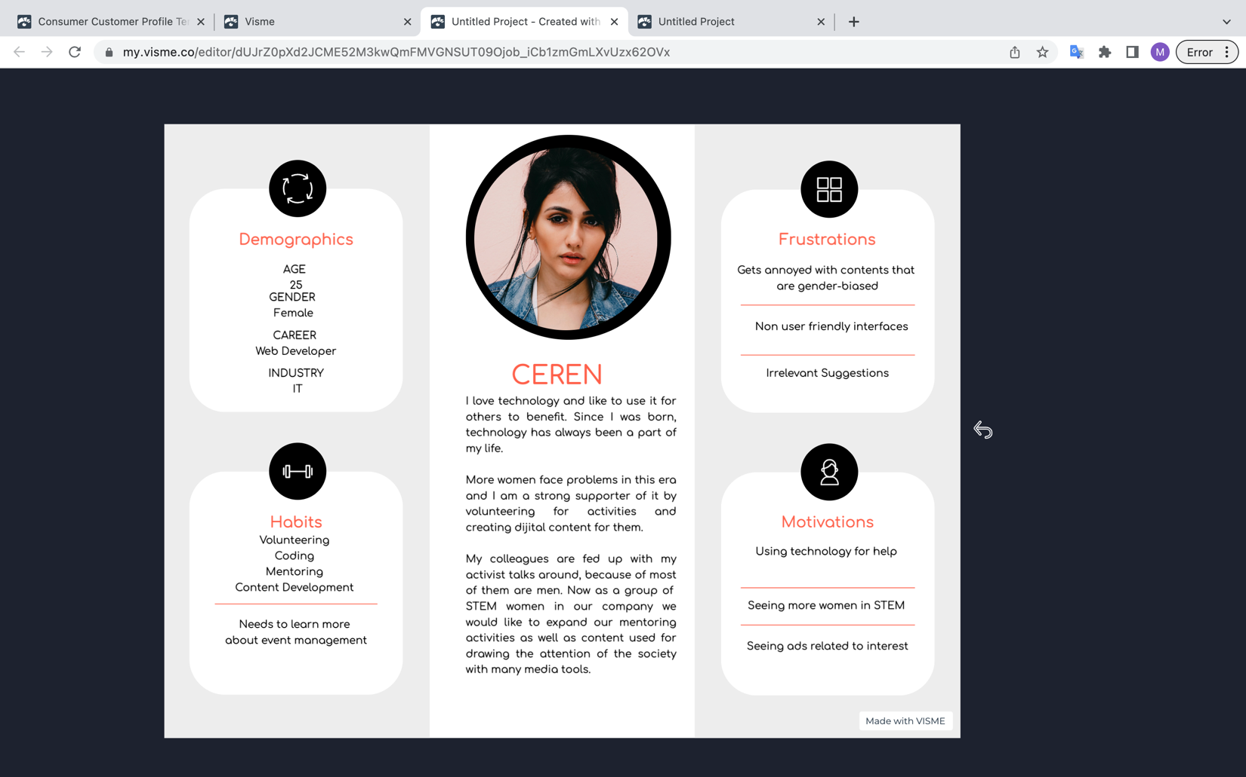

# 7.SCENARIOS

Two concreate scenarios have been created aligning with both personas’ aims showed on personas.

**Scenario1**

Aby has recently been working on choreographies that are going to be performed next summer in Ibiza. She needs to create playlists including upbeat music and rhythms that can entertain guests in the hotel. She searches songs from album and playlists, listens to them carefully and she adds songs to her playlist.

|  |  |
| --- | --- |
| Actor | Aby |
| Motivator | Upcoming summer performances in Ibiza |
| Intention | She needs songs that are energetic and go well with dance. |
| Action | She searches for songs, listens to them. |
| Resolution | She adds the songs chosen to playlist. |

**Scenario2**

Ceren wishes to create and share a playlist including podcasts that are created by activists to raise awareness on women issues in society. She needs to find podcasts that are good in terms of context and speakers. She browses and search for podcasts, listen to them, adds the ones she likes to playlist and share it on social media platforms.

|  |  |
| --- | --- |
| Actor | Ceren |
| Motivator | Raising the awareness on women issues in society |
| Intention | She looks for podcasts created by activists. |
| Action | She searches or browse for podcasts and listen to them. |
| Resolution | She adds podcasts to playlist and share it on social media. |

# 8.PROTOTYPE DESIGN

Before starting to create the prototype, some system requirements have been taken into consideration as follows:

1. Login page
2. Navigation Menu-top
3. Side menu-Shortcuts
4. Account page
5. Player
6. Share panel search
7. Help page
8. Creating playlist
9. Profile page
10. Logo

For the purpose of developing a consistent product, items placing many times on the prototype designed as components that allow designers to reflect any changes to items automatically.

In the mid-fidelity prototype, in order to create a minimalist interface three different colours red, grey and black have been applied to elements with white background that creates a contrast increasing perception; instead of sharp items, circular corners with Radius 5 have been adopted. Text type is Impact with colour code of D9001B or Black.

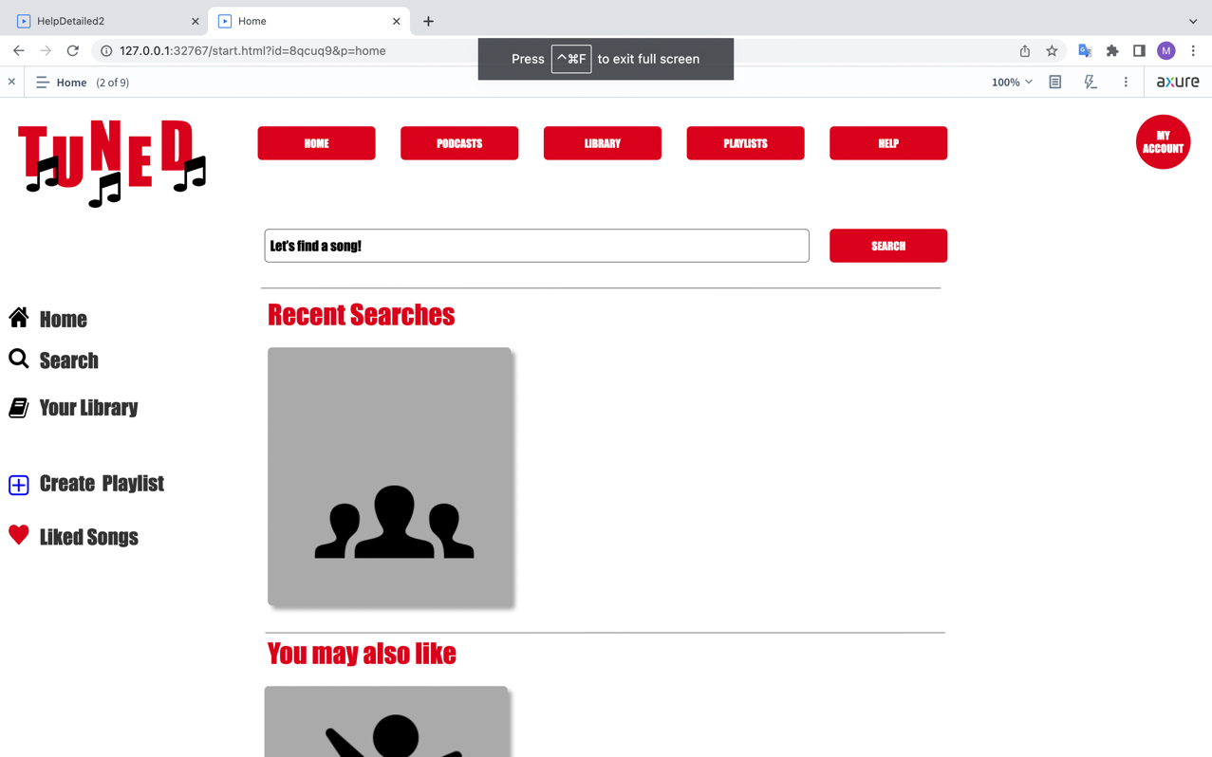

Due to the fact that many streaming platforms have a wide range of content, likewise a grid layout has been implemented to mid-fidelity prototype design with the aim of easily position the items and provide a smooth navigation among them. Spotify’s left side menu has also been adopted by the ease of use with its shortcuts.

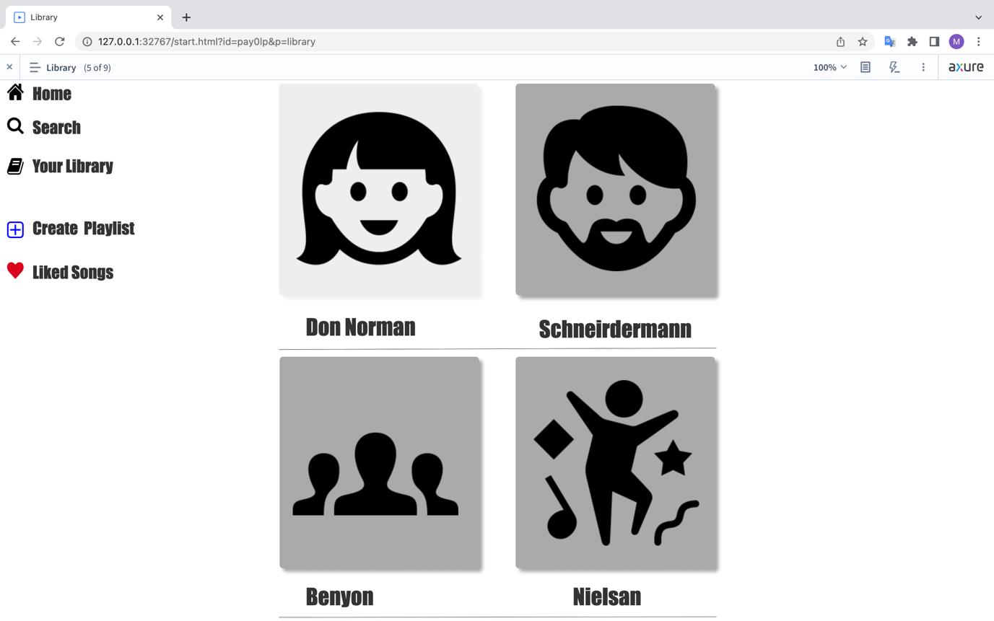

In this section, mid-fidelity prototype named TUNED has been evaluated with Nielsen’s 10 heuristics used previously above.

1. **Visibility of system status**

For this guideline, the system provides feedbacks users that the system works properly and inform users about their actions during their experience.

When a user moves the mouse over the icons or menus on pages, the opacity of them changes and also let users that is a clickable option by changing the cursor’s image from arrow to hand.

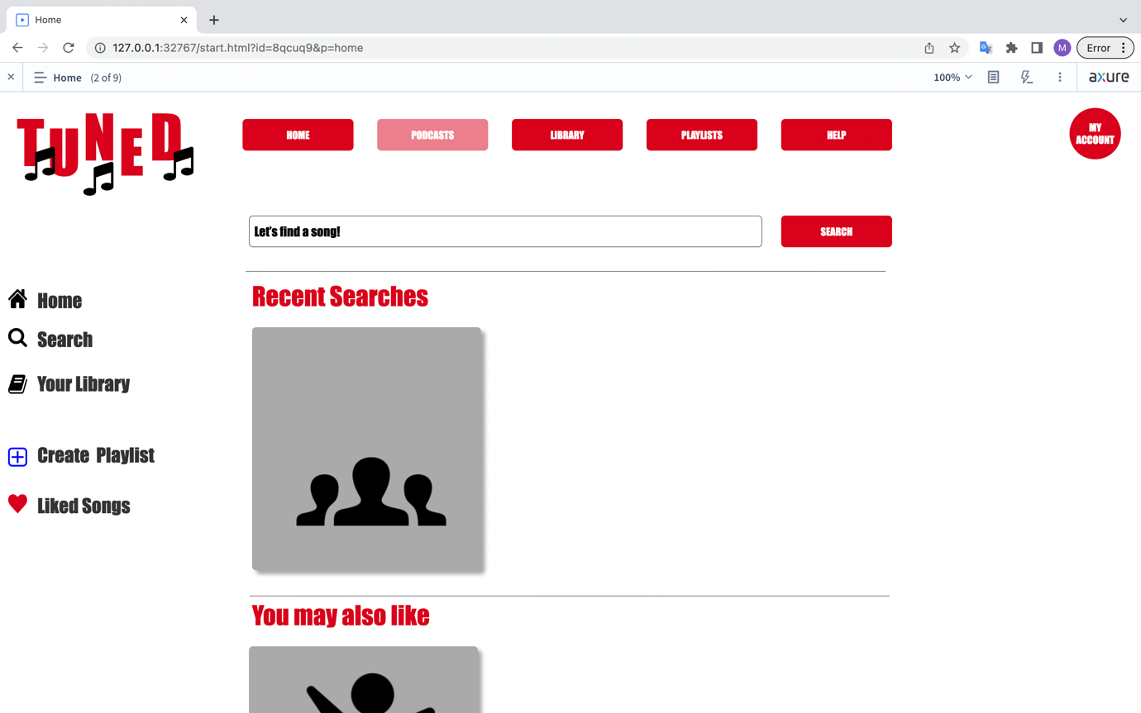

When a user attempts to add a song to a playlist, a message informing user appears.

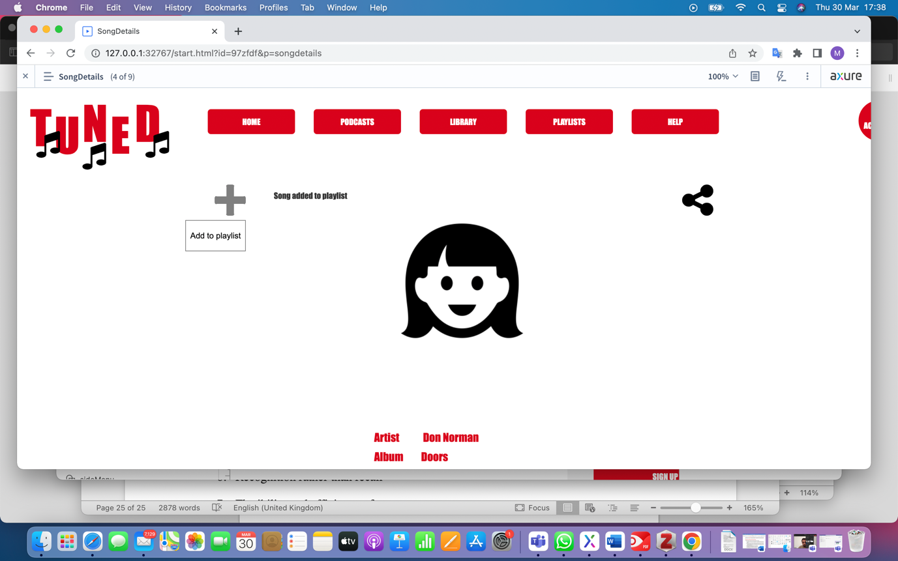

1. **Match between system and the real world**

Icons that users are familiar from their previous experience have been implemented to prototype during the design.

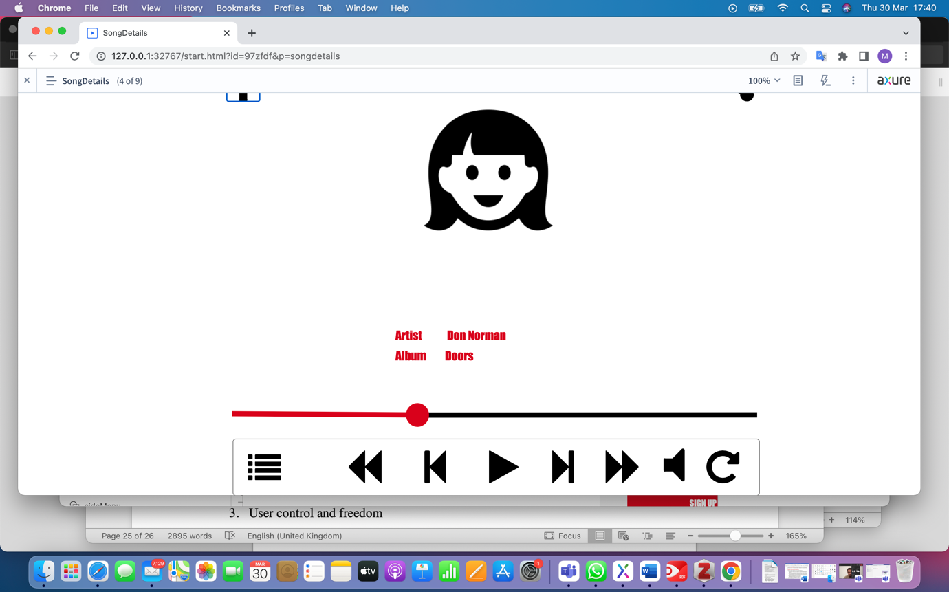

1. **User control and freedom**

Due to the limited time and scope of the project and limited ability to use of Axure interface, there is no solid implementation of this heuristic.

1. **Consistency and standards**

It is clear that, the standards of the elements, colours, using components in design keep consistency all part of the experience, from sign in to sign out.

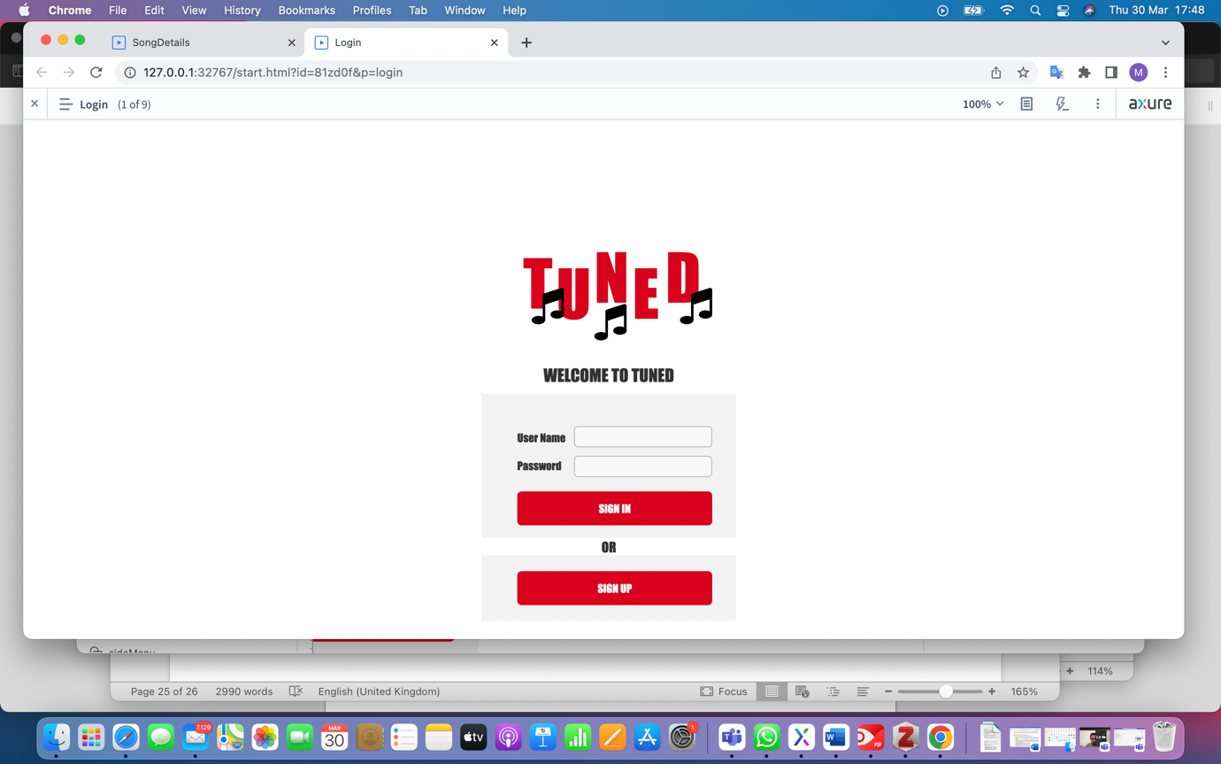

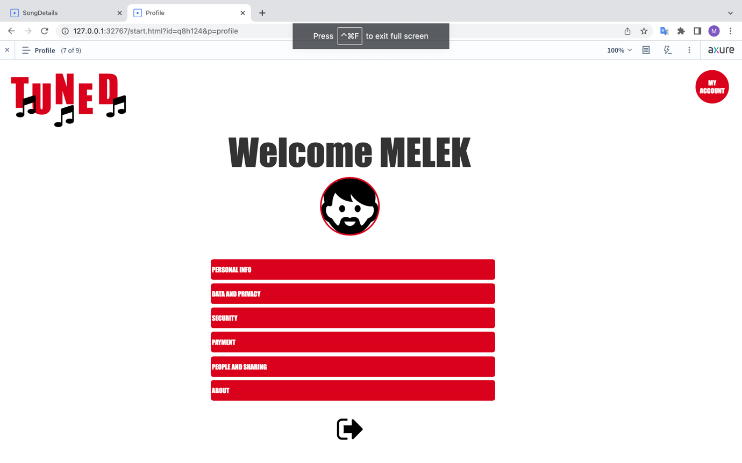

1. **Error prevention**

Due to the limited time and lack of experience of Axure interface, further developments cannot be done.

1. **Recognition rather than recall**

On the home page there are previous research and suggestions regarding the users’ preference.

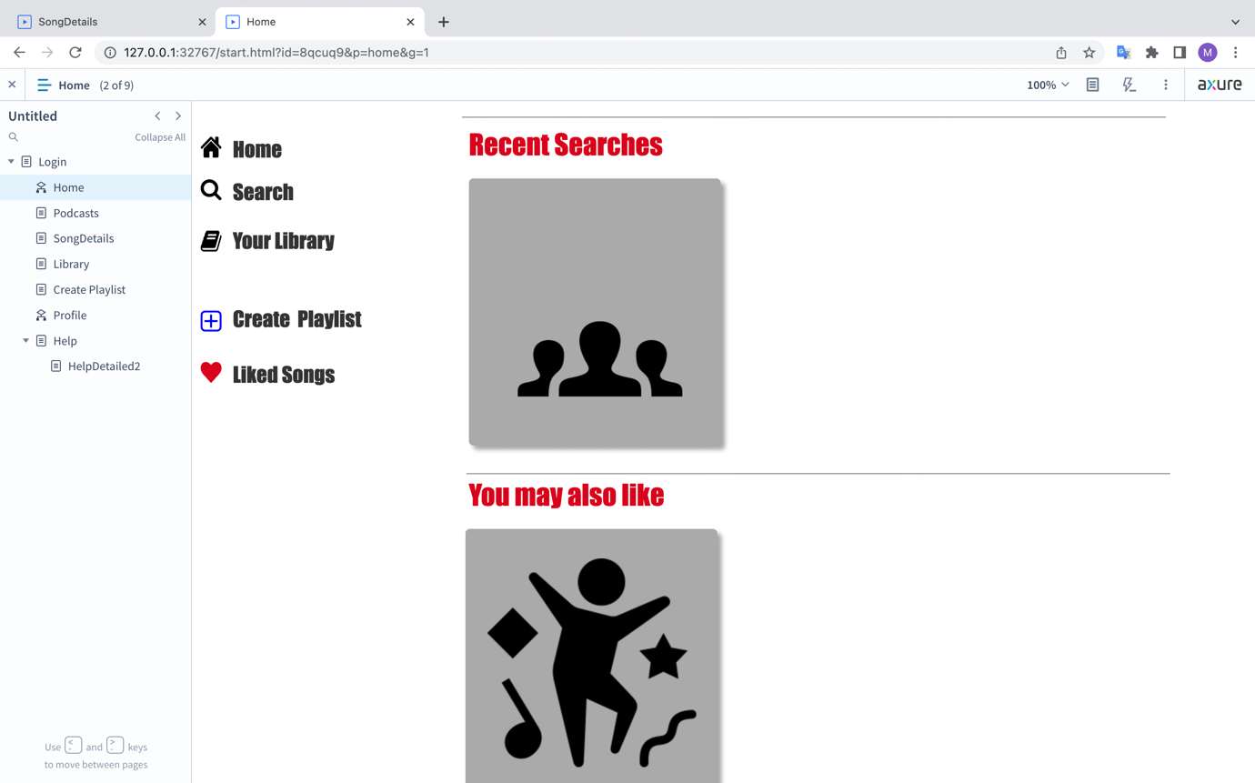

1. **Flexibility and efficiency of use**

For both novice and expert users, navigation and shortcuts provide a smooth and desirable experience.

1. **Aesthetic and minimalist design**

Using not more than three colours on a white background, avoiding to use unrelated content for each individual page creates a aesthetic appearance and draws the users attention.

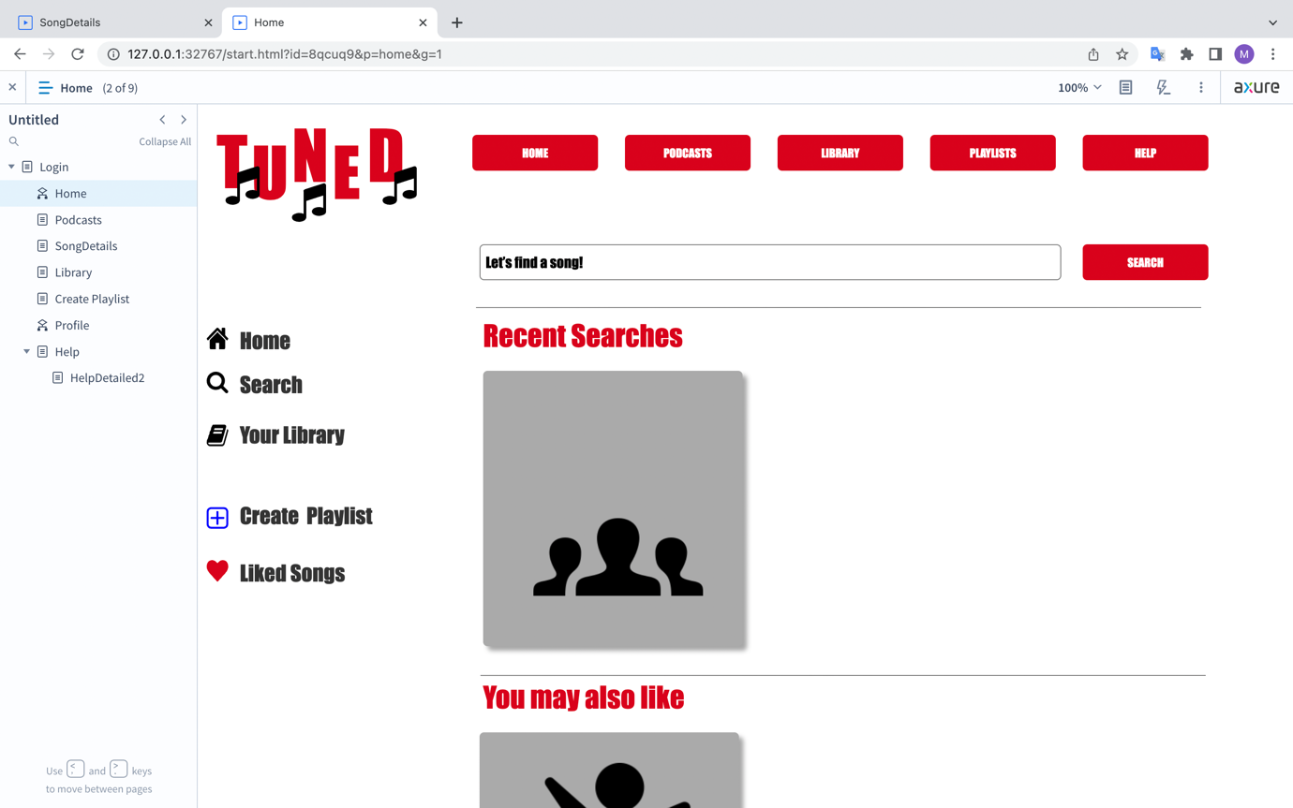

1. **Help users recognize, diagnose, and recover from errors**

Message boxes warning users can be accepted under this heuristic.

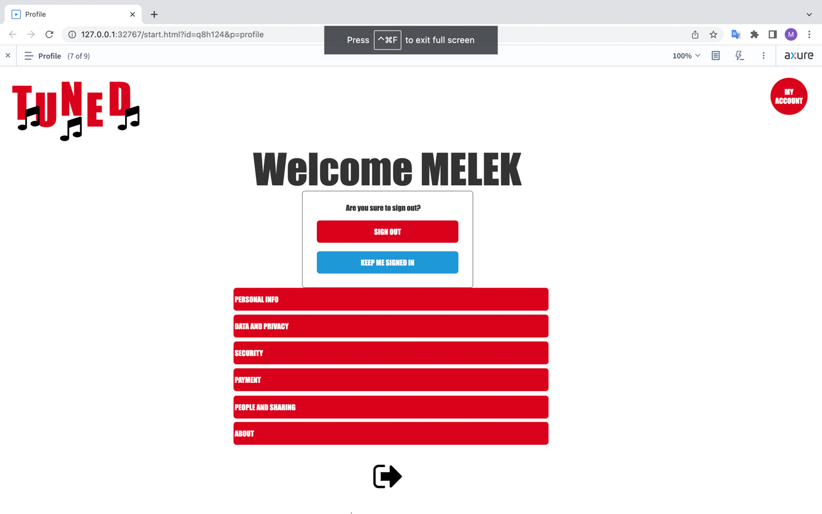

1. **Help and documentation**

For this part, a variety of help mechanisms implemented as follows:

1. **Proactive help**

When user drag the cursor on items, pop up giving instructions on what it is for appears.

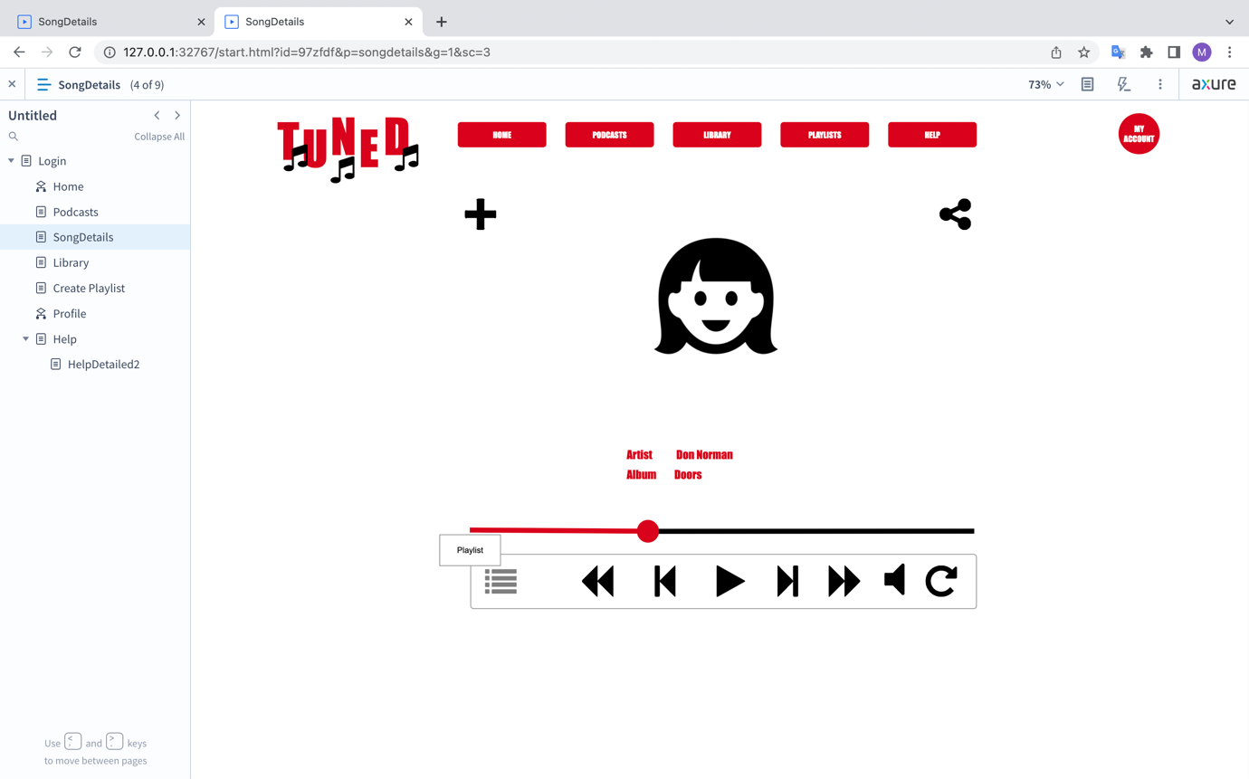

1. **Categorised help**

For more detailed help, users can apply for help menu on right top and a well detailed and categorised content welcomes users. It is also supported with search box.

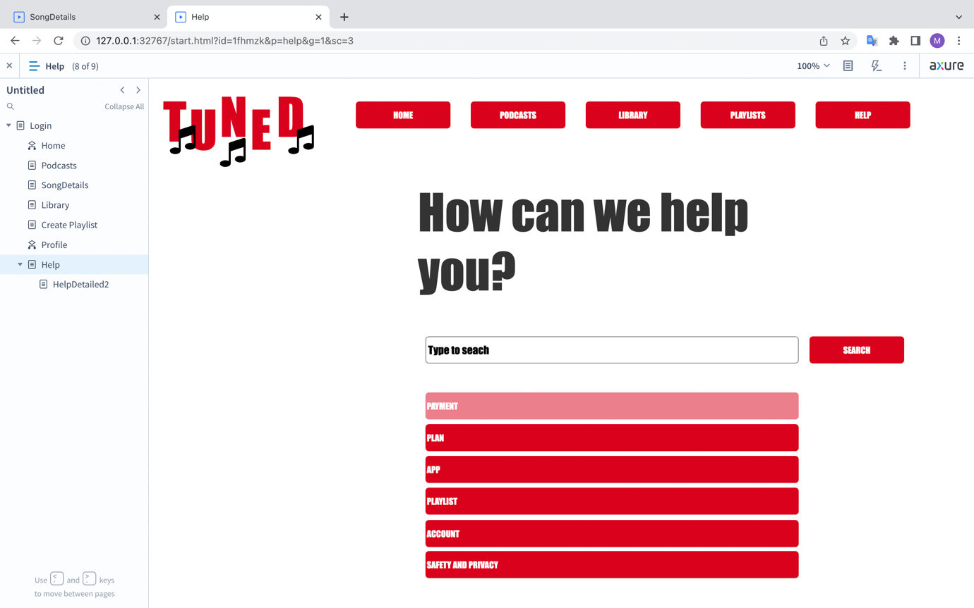

1. **Help supported both text and video as well as subtitles.**

Each help category provides detailed explanation regarding the help required, supported with video and subtitles which is also able to turn on and turn off. Moreover, articles may be related to user’s need is also visible on right hand side.

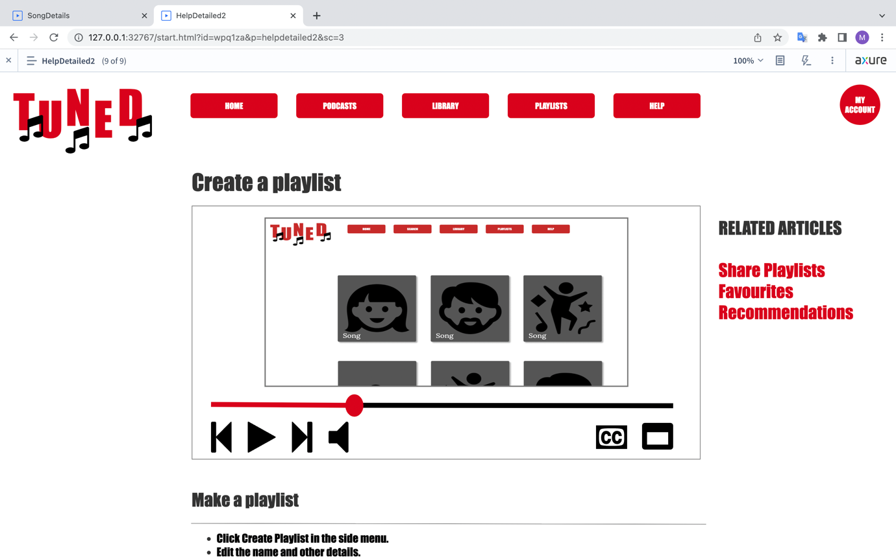

# 9.CONCLUSIONS

In this study, usability and usability issues have been evaluated by using one of most famous heuristics, Nielsen’s 10 heuristics in order to create a mid-fidelity prototype focusing on creating playlists either individually or as a group.

A heuristic evaluation has been undertaken for two different music streaming platform Spotify and YouTube Music. Some usability issues have been found; also, good applications have been highlighted during the test. Finding gathered evaluation has also been into consideration while creating the prototype.

It is important that since technology advances rapidly, guidelines and heuristics should focus on cutting-edge technologies’ usability problems. Due to the fact that AR and VR have placed in many areas, new rules and standards can be developed to undertake evaluations which allow experts to evaluate many devices at the same time(Mobile phone, AR glass for instance).

One another major point is that expert should study with other colleagues in social and cognitive sciences in order to provide more inclusive designs. Moreover, in future it will likely be possible that AI would have taken a part in our daily life. Thus, it is essential to act and develop guidelines with subject matter experts prior to AI takes the control for manipulating our experience with technology.

# REFERENCES

Blomkvist, S., 2002. Persona–an overview. Retrieved November, 22, p.2004

Broadbent, E., Gougoulis, J., Lui, N., Pota, V., & Simons, J. (2017). Generation Z: Global citizenship survey. Retrieved from https://www.varkeyfoundation.org/what-we- do/policy-research/generation-z-global-citizenship-survey

Burnett, M., McCallum, D. C., & Payne, S. J. (2016). GenderMag: A methodology for evaluating software's gender inclusiveness. In Proceedings of the 2016 CHI Conference Extended Abstracts on Human Factors in Computing Systems (pp. 349-362). ACM. doi: 10.1145/2851581.2892490

Burnett, M., McCallum, D. C., & Payne, S. J. (2016). GenderMag: A methodology for evaluating software's gender inclusiveness. In Proceedings of the 2016 CHI Conference Extended Abstracts on Human Factors in Computing Systems (pp. 349-362). ACM. doi: 10.1145/2851581.2892490

Burnett,M Simone Stumpf, Jamie Macbeth, Stephann Makri, Laura Beckwith, Irwin Kwan, Anicia Peters and William Jernigan

GenderMag: A Method for Evaluating Software’s Gender Inclusiveness

doi:10.1093/iwc/iwv046

Margaret Burnett, Simone Stumpf, Jamie Macbeth, Stephann Makri, Laura Beckwith, Irwin Kwan, Anicia Peters, and William Jernigan. 2016. GenderMag: A method for evaluating software’s gender inclusiveness. Interacting with Computers 28, 6 (2016), 760–787.

Cheung, J., Glass, S., McCarty, D., & Wong, C.K. (2017). Uniquely Generation Z: What brands should know about today’s youngest consumers. Retrieved from <https://www.ibm.com/downloads/cas/9PPL5YOX>

Cooper, A, Reimann, R, & Cronin, D 2007, About Face 3 : The Essentials of Interaction Design, John Wiley & Sons, Incorporated, Hoboken. Available from: ProQuest Ebook Central. [30 March 2023].

GenderMag, <https://gendermag.org/index.php>

Götting, Marie Charlotte, <https://www.statista.com/statistics/291712/digital-music->streaming-by-demographic-group-uk/#statisticContainer

Hassenzahl, M., & Tractinsky, N. (2006). User experience--a research agenda. Behaviour & Information Technology, 25(2), 91-97.

Hertzum, M., & Jacobsen, N. E. (2001). The evaluator effect: a chilling fact about usability evaluation methods. International Journal of Human-Computer Interaction, 13(4), 421-443.

Miner, K. N., Walker, J. M., Bergman, M. E., Jean, V. A., Carter-Sowell, A., January, S. C. and Kaunas, C. (2018) “From ‘Her’ Problem to ‘Our’ Problem: Using an Individual Lens Versus a Social-Structural Lens to Understand Gender Inequity in STEM,” Industrial and Organizational Psychology. Cambridge University Press, 11(2), pp. 267–290. doi: 10.1017/iop.2018.7.

Nielsen, J. (1993). Usability engineering. Academic Press.

Nielsen, Jakob. "How to conduct a heuristic evaluation." Nielsen Norman Group 1.1 (1995): 8

Nielsen, Jakob. "Ten usability heuristics." (2005). <https://www.nngroup.com/articles/ten-usability-heuristics/>

Nielsen, L. (2002). Personas. In J. A. Jacko & A. Sears (Eds.), The human-computer interaction handbook: Fundamentals, evolving technologies and emerging applications (pp. 355-366). Lawrence Erlbaum Associates.

Oxford English Dictionary. (2021). Skeuomorphism. Oxford University Press. <https://www.oed.com/view/Entry/175763>.

Pant, A., 2015. Usability evaluation of an academic library website. The Electronic Library, 33(5), 896–915. https://doi.org/10.1108/EL-04-2014-0067 )

Rosa Yáñez Gómez,1Daniel Cascado Caballero,1and José-Luis Sevillano

Heuristic Evaluation on Mobile Interfaces: A New Checklist

<https://doi.org/10.1155/2014/434326>

Rubin, R. S., & Chisnell, D. (2008). Handbook of usability testing: how to plan, design, and conduct effective tests. John Wiley & Sons.

Szabo, P. W., 2017. User experience mapping : get closer to your users and create better products for them. Packt Publishing.

Williams, A. & Hodges, N. J., (2020) “Generation Z and Socially Responsible Fashion Consumption: Exploring the Value-Action Gap”, International Textile and Apparel Association Annual Conference Proceedings 77(1). doi: <https://doi.org/10.31274/itaa.11930>.